
INDUSTRY REPORT
Finance & Insurance in the US
Apr 2026

About

IBISWorld
IBISWorld specializes in industry research with coverage on thousands of global industries. Our comprehensive data and in-depth analysis help businesses of all types gain quick and actionable insights on industries around the world. Busy professionals can spend less time researching and preparing for meetings, and more time focused on making strategic business decisions.

Table Of Contents | Standard

1. About 4
Codes 4
Definition 4
Related Terms 4
What's Included 4
Companies 5
Related Industries 5
Additional Resources 5
2. At a Glance 6
Key Takeaways 6
Products and Services 7
Major Players 8
Key External Drivers 9
Industry Structure 9
SWOT 10
Executive Summary 10
3. Performance 12
Highlights 12
Key Takeaways 12
Performance Snapshot 13
Outlook 21
Life Cycle 24
4. Products and Markets 25
Key Takeaways 25
Products and Services 25
Major Markets 29
International Trade 31
5. Geographic Breakdown 32
Key Takeaways 32
Business Locations 33
6. Competitive Forces 38
Key Takeaways 38
Concentration 38
Barriers to Entry 39
Substitutes 40
Buyer & Supplier Power 41
7. Companies 43
Key Takeaways 43
Market Share 44
Companies 45
8. External Environment 48
Key Takeaways 48
External Drivers 48
Regulation & Policy 51
Assistance 52
9. Financial Benchmarks 53
Key Takeaways 53
Cost Structure 53
Key Ratios 56
10. Key Statistics 58
Industry Data 58

1. About
https://my.ibisworld.com/us/en/industry/52/about

Codes
NAICS 2017 - USA | 52
NAICS 2022 - USA | 52

Definition
This sector comprises operators primarily engaged in financial transactions and in facilitating financial transactions. Three principal types of activities are identified, including raising funds by taking deposits, issuing securities and, in the process, incurring liabilities.

Related Terms

ASSETS UNDER MANAGEMENT (AUM)
The assets, such as equities, fixed income, real estate and alternative assets, managed on behalf of clients.

UNDERWRITING
The process where insurers assess the risks to insure and decide how much to charge for those risks.

HARDENING PRICE CYCLE
A period of time when insurance providers raise premium prices to improve profit and increase capital reserves.

What's Included
- National and state commercial banks
- Federal and state savings banks
- Federal and state credit unions
- Credit card issuing
- Sales financing
- Loan and mortgage brokerages
- Portfolio management
- Investment advice
- Insurance carriers
- Agencies, brokerages and other insurance-related activities

Companies
- Unitedhealth Group Incorporated

Related Industries

Industries in the Same Sector
- Competitors:
  - No data available
- Complementors:
  - No data available

International Industries
- Global Insurance Brokers & Agencies
- Finance in Australia
- Banking in New Zealand

Additional Resources
- The United States Federal Reserve System
- Insurance Information Institute
- National Association of Insurance Commissioners
- American Council of Life Insurers

2. At a Glance
https://my.ibisworld.com/us/en/industry/52/at-a-glance
Revenue  $7.8tr  ’21-’26 ↑ 4.2 %  ’26-’31 ↑ 2.1 % | Employees  9m  ’21-’26 ↑ 2.9 %  ’26-’31 ↑ 2.2 % | Businesses  1m  ’21-’26 ↑ 2.0 %  ’26-’31 ↑ 1.9 %
Profit  $2.2tr  ’21-’26 ↑ 7.2 % | Profit Margin  28.8%  ’21-’26 ↑ 3.8 pp | Wages  $1.1tr  ’21-’26 ↑ 1.2 %  ’26-’31 ↑ 2.1 %

Key Takeaways

Performance
- As the economy continues to expand, per capita disposable income will increase. This will lead to increased financial activity by consumers, which will be processed and facilitated by operators in the sector.
- Interest rate cuts in the latter part of the period have a varied effect on the sector. Lower interest rates reduce interest income for various businesses across the sector and lower rates will increase demand for industries that issue loans.

Products and Markets
- Consumers and businesses increased their demand for financing provided by operators that provide these services despite elevated interest rates. Interest rates have been cut in the latter part of the period as inflationary pressures ease.
- Operators in the sector provide consumers with debit and credit cards to make purchases and the banking and depository services they need on a daily basis.

Products and Services
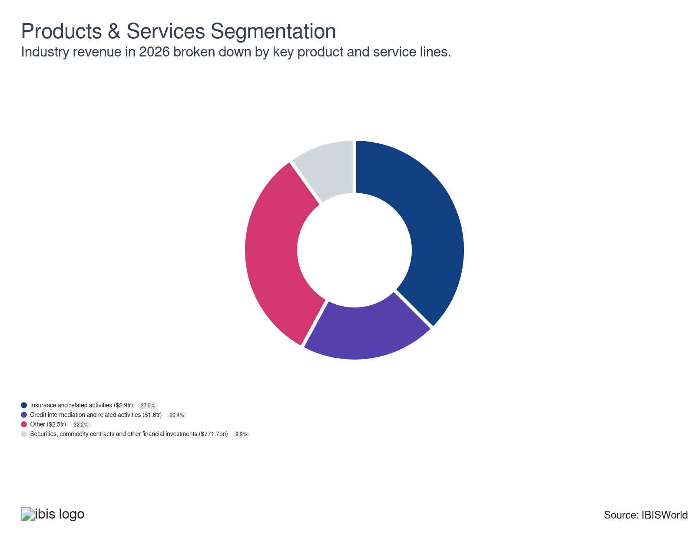

Major Players
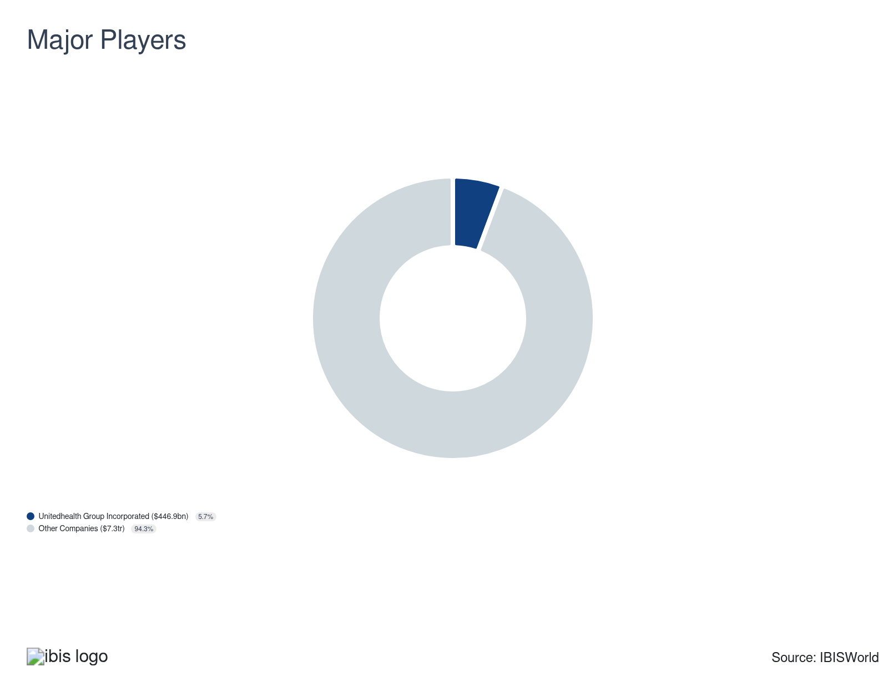

Key External Drivers
Key External Drivers | Impact
Per capita disposable income | Positive
Corporate profit | Positive
Consumer confidence index | Positive
Regulation for the Banking sector | Negative

Industry Structure
Characteristic | Level | Trend
Concentration | Low
Barriers To Entry | Moderate | Steady
Regulation and Policy | High | Steady
Life Cycle | Mature
Revenue Volatility | Moderate
Assistance | Low | Steady
Competition | High | Steady
Innovation | Moderate

SWOT
Strengths  High Profit vs. Sector Average  Low Customer Class Concentration  Low Product/Service Concentration  Low Capital Requirements | Weaknesses  Low Revenue per Employee | Opportunities  High Revenue Growth (2021-2026)  High Revenue Growth (2026-2031)  High Performance Drivers  Per capita disposable income | Threats  Low Revenue Growth (2005-2026)  Low Outlier Growth  Consumer confidence index

Executive Summary

On loan: Businesses are expected to increase their borrowing levels as corporate profit grows
Revenue growth for the Finance and Insurance sector has varied in recent years, as a result of differing economic trends. The sector plays a vital role in facilitating necessary financial transactions between consumers, businesses and government agencies. The core services provided by operators in this sector include providing insurance products needed by businesses and consumers to legally operate corporations and assets. These services include offering, borrowing and depository services needed to finance new projects and investing to create and preserve investors' assets.
A wide range of operators in the sector benefited from improving macroeconomic conditions over the past five years. For example, the Fed increased interest rates to curb historically high inflation throughout the period. Although higher interest rates increased investment income from fixed-income securities, higher rates limited loan and mortgage demand due to elevated borrowing rates. In the latter part of the period, the Fed cut interest rates, enabling consumers to borrow money at lower interest rates, which will increase loan demand. Although reduced rates will hinder investment income from debt securities. In addition, the growing prevalence of emerging technologies such as AI and data analytics tools has streamlined operations and helped reduce operational costs.
These tools help industry companies identify trends and potential risks more efficiently. Also, the emergence and growth in popularity of alternative asset classes such as cryptocurrencies and event contracts in prediction markets has driven demand and transaction volumes, supporting revenue growth. Over the past five years, industry revenue grew at a CAGR of 4.2% to $7,794.6 billion, including a 1.9% jump in 2026 alone. Industry profit has also climbed and will account for an estimated 28.8% of revenue in the current year.
During the outlook period, sector revenue will increase at a CAGR of 2.1% to $8,637.0 billion over the next five years. As the economy continues to improve, per capita disposable income is expected to increase. This will likely lead to increased financial activity by consumers, which will likely be processed and facilitated by operators in the sector. Interest rate growth is also expected to be minimal compared to the significant growth during the current period. Limited interest rates will reduce interest income for operators but will increase the volume of loans. In addition, the acquisition of financial technology start-ups to compete in a changing technological and financial environment will increase.

3. Performance
https://my.ibisworld.com/us/en/industry/52/performance

Highlights
Revenue  $7.8tr  2021-26 CAGR ↑ 4.2 %  2026-31 CAGR ↑ 2.1 % | Employees  9m  2021-26 CAGR ↑ 2.9 %  2026-31 CAGR ↑ 2.2 % | Businesses  1m  2021-26 CAGR ↑ 2.0 %  2026-31 CAGR ↑ 1.9 %
Profit  $2.2tr  2021-26 CAGR ↑ 7.2 % | Profit Margin  28.8%  2021-26 CAGR ↑ 3.8 pp

Key Takeaways
- As the economy continues to expand, per capita disposable income will increase. This will lead to increased financial activity by consumers, which will be processed and facilitated by operators in the sector.
- Interest rate cuts in the latter part of the period have a varied effect on the sector. Lower interest rates reduce interest income for various businesses across the sector and lower rates will increase demand for industries that issue loans.

Performance Snapshot
Revenue: | ↑ 2021-26 Revenue CAGR +4.2%
Revenue  $7.8tr  ’21-’26 ↑ 4.2 %  ’26-’31 ↑ 2.1 % | 2026 Revenue Growth  ↑ 1.9 % | Revenue Volatility  Moderate
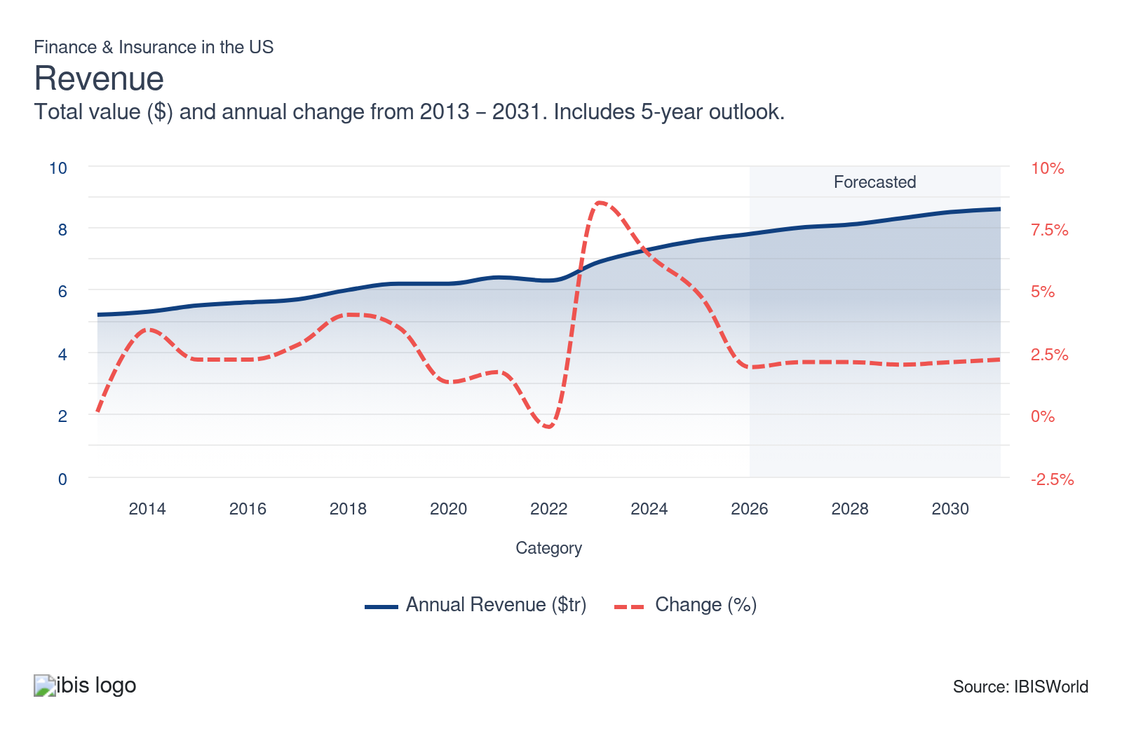
Employees: | ↑ 2021-26 Employees CAGR +2.9%
Employees  9m  ’21-’26 ↑ 2.9 %  ’26-’31 ↑ 2.2 % | Employees per Business  8  ’21-’26 ↑ 0.9 %  ’26-’31 ↑ 0.2 % | Revenue per Employee  $902k  ’21-’26 ↑ 1.3 %  ’26-’31 ↓ 0.1 %
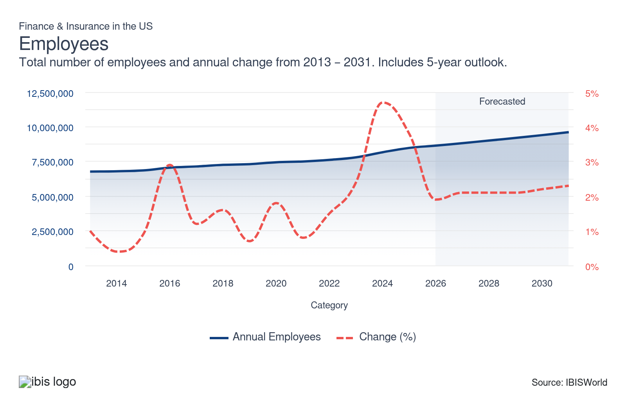
Businesses: | ↑ 2021-26 Business CAGR +2.0%
Businesses  1m  ’21-’26 ↑ 2.0 %  ’26-’31 ↑ 1.9 % | Employees per Business  8  ’21-’26 ↑ 0.9 %  ’26-’31 ↑ 0.2 % | Revenue per Business  $7.0m  ’21-’26 ↑ 2.1 %  ’26-’31 ↑ 0.1 %
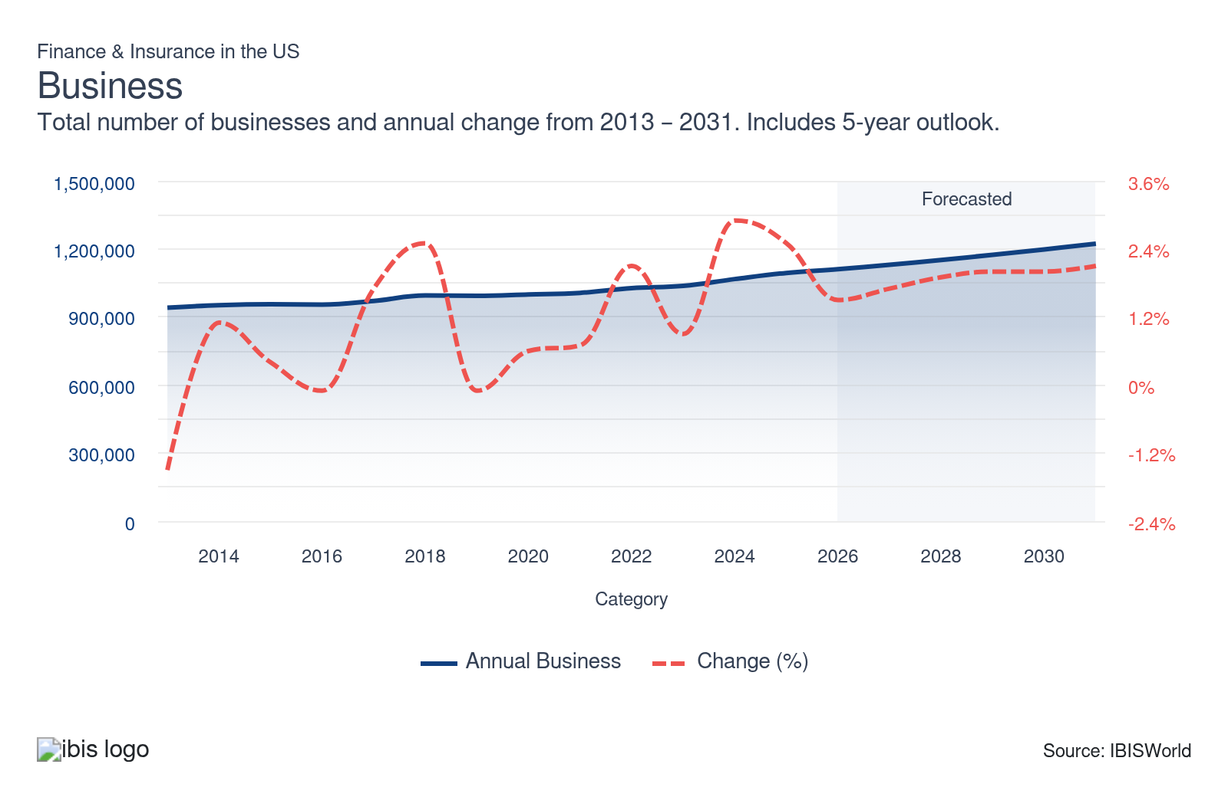
Profit: | ↑ 2021-26 Profit CAGR +7.2%
Total Profit  $2.2tr  ’21-’26 ↑ 7.2 % | Profit Margin  28.8%  ’21-’26 ↑ 3.8 pp | Profit per Business  $2.0m
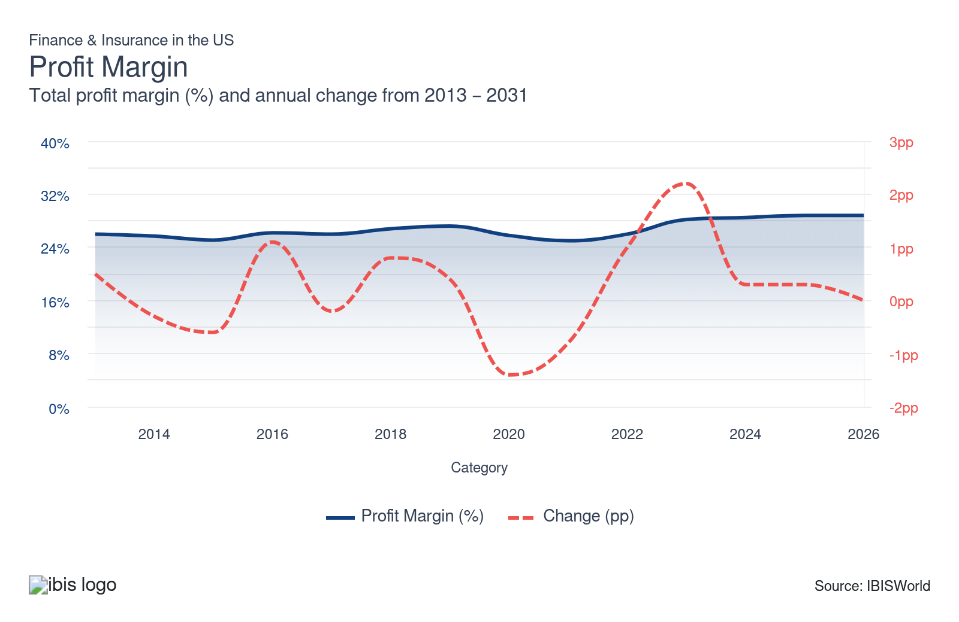
Current Performance
Current Performance

What's driving current industry performance?

The growing use of technology and digital platforms is streamlining processes
- The growing prevalence of AI and data analytics tools streamlined processes such as underwriting and claims processing. These technological innovations improve product offerings and customer experiences. In addition, these technologies reduce operational costs for companies in the sector. AI tools and models support real-time decisions, processing and personalized offers across channels and services.
- Data analytic tools became crucial for companies in the finance and insurance sector. Data analytics tools enable finance companies to identify potential investment risks and maximize potential returns while limiting investment risks. In addition, data analytics tools enable insurance companies to identify potential areas with significant risk concerning natural disasters, pricing premiums accordingly to remain competitive.
- The growing use of mobile and digital platforms has enhanced customer-centric innovations that cater to individual's personal needs and preferences, enhancing the customer's experience. These digital and mobile platforms also improve customer accessibility. The growth of business conducted online and internet traffic volumes has accelerated this trend during the period.
- For insurance companies, AI-driven claims and underwriting reduce cycle times and loss-adjustment expenses. AI tools help generate risk and fraud scores, which are increasingly becoming embedded in core platforms. Intensifying catastrophe losses, auto severity and rising operating costs make traditional claims models more expensive and unsustainable, boosting demand for technological innovation and AI tools.

The sector experienced economic volatility and capital reallocation
- The sector adapted its investment strategies in response to interest rate volatility, inflationary pressures and the affects of trade wars, which have resulted in fluctuating trade policies and tariff rates. Economic shifts influenced investment returns and consumer appetite for various investment products and services. The ongoing conflict in Iran impacted energy markets in 2026 and will affect inflation and Federal Reserve interest rate decisions in the near future.
- The industry encountered rising interest rates throughout the period despite interest rate cuts in the latter part of the period. Higher rates encouraged individuals to increasingly seek fixed-income securities like bonds and US treasuries. Although as interest rates are slashed, investors are increasingly shifting capital from fixed-income securities into the equity market. However, interest rates remain elevated, driving interest income earned among finance and insurance companies from fixed-income securities and interest on loans underwritten.
- In addition, fluctuating economic conditions triggered real-time product redesign and pricing competition among finance and insurance companies as products and services are considered mature. Economic volatility made traditional insurance offerings less attractive to consumers, particularly for property, casualty and commercial coverage, as consumers preferred insurance plans with flexible solutions. Insurers introduce adaptable policies and pricing algorithms, aligning coverage more closely with market conditions.

The sector encountered a rise of alternative assets and a digital transformation
- Finance and insurance companies are investing significantly more in alternative assets, such as private credit, infrastructure and real estate. Volatile markets have pushed firms to seek higher returns and diversify portfolio assets while mitigating risks by spreading capital across various asset classes and beyond traditional equities and bonds. Companies have utilized advanced analytic tools to evaluate and monitor complex investments.
- The sector experienced a surge in products and services linked to cryptocurrencies and digital assets, including Bitcoin, Ethereum and decentralized finance (DeFi) tokens. The growing adoption and institutional investment in digital assets have created demand for cybersecurity, as they pose unique risks compared to other assets. Insurers are increasingly offering specialty policies regarding cryptocurrency assets for comprehensive coverage.
- Finance companies are rapidly developing and underwriting event contracts, including derivative products tied to specific, defined occurrences like weather events, cyber breaches, market fluctuations and sporting events. Clients demand these products, enabling them to earn money by making accurate decisions across a wide range of topics. Finance companies use third-party data feeds and smart contracts to automate settlements and expand access to a broader base of users.

The exuberant house market of recent years
- To stimulate growth during the economic downturn at the onset of the period, low interest rates made it affordable for individuals to secure mortgages. The reduced rates drove up housing prices. Although interest rate increases in the middle of the period increased borrowing costs significantly, slowing demand for mortgages.
- Higher interest rates resulting in increased borrowing costs, therefore, loan volume demand shrank as consumers found it more difficult to take a large loan with significant interest. However, increases in access to credit helped to mitigate declines in demand for mortgages as some consumers were able to take out a mortgage despite higher borrowing costs.
- Interest rate cuts in the latter part of the period have resulted in demand for loans and mortgages to climb as debt and borrowing costs have slipped. Even as mortgage volumes climb due to falling rates, the interest income earned on each loan will also decrease, potentially hindering industry profit margins.

What influences industry volatility?

The fluctuation of interest rates impact revenue
- For typical depository institutions, such as commercial banks, higher prevailing interest rates raise borrowing costs and reduce loan demand. High interest rates discourage businesses and customers from taking out loans due to the elevated associated costs, although the sector benefits from increased interest income during a high-interest-rate environment.
- A rise in interest rates throughout the period hurt demand for credit and lending, though the boost in interest income from higher loan rates offset declines. As a result, higher interest income for each loan sustained revenue growth.
- However, the Federal Reserve slashed rates in the latter part of the period, driving demand for credit and lending but hindering interest income on loans underwritten. The Fed will monitor economic changes and impacts on the economy stemming from the conflict in Iran before making interest rate decisions in the near future.
- For most insurance companies, the returns from investment activity influence revenue volatility. Investment income is dependent on the whims of the markets, as net gains from equity and bond investments are a big portion of industry revenue.

Economic uncertainty and market volatility cause revenue instability
- Aggregate household debt is historically reflective of greater loan demand and higher loan demand leads to higher revenue. The aggregate household debt has climbed, which resulted in increased loan demand and increased revenue for the industry, despite the high-interest-rate environment.
- In normal situations, people reduce debt when interest rates increase. Although as interest rates are cut, people will increase their debt as interest rates fall. The current and increasing economic hardships are forcing households to increase their debts despite the elevated interest rates.
- During periods of economic uncertainty, consumers and businesses postpone major financial decisions, limiting demand for insurance coverage, loans and investment products. In addition, economic volatility raises default rates on loans and increases insurance claims, particularly in commercial lines, forcing companies to increase reserves and generally reduce lending activities.
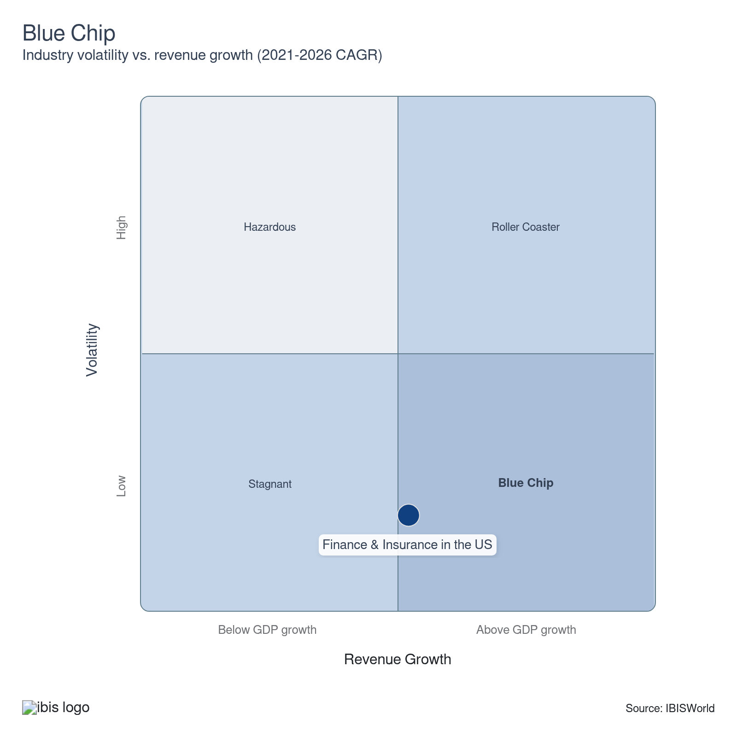

How do successful businesses overcome volatility?
Having an extensive distribution/collection network
Having an extensive customer base to cross-sell a range of products and services is imperative. Having an extensive customer base enables companies to sell more products and services.
Develop credible and soundly based investment strategies
Creating reliable investment strategies helps to manage market uncertainties, limit risk exposure and maximize potential gains which gives clients confidence and ensures long-term profitability and growth.
Outlook | ↑ 2026-31 Revenue CAGR +2.1%

What's driving the industry outlook?

The growth of AI and digitization will continue to change the sector
- Insurers are accelerating the adoption of AI and machine learning in underwriting processes to analyze massive, real-time datasets and behavioral inputs. AI models allow for improved and efficient risk assessment and accurate personalized pricing, outpacing legacy rules-based systems. Insurance carriers will increasingly deploy automation to minimize manual work and meet rising digital-first customer expectations.
- Advanced machine learning refines product development based on customer input and market performance data. Data-driven innovation allows rapid adaptation to changing consumer demand and regulatory requirements. Finance and insurance firms use feedback loops to launch new products and services and iterate features in response to customer trends, capitalizing on a constantly shifting market. Companies that can stay ahead of trends and identify new trends will have an edge in the sector.
- Finance companies will also increasingly implement AI and technological tools. Also, finance companies use data analytics tools to monitor market trends and shift through large data sets to identify investment opportunities, mitigate risks and seek out trends. This approach will better enable finance companies to maximize returns while mitigating risks.
- The sector will continue to experience digital and embedded financial platforms. Consumer preferences are shifting from standalone banking products to integrated digital ecosystems, with mobile apps becoming the primary interface for payments, savings, investing and credit. Consumers will expect seamless user experiences paired with various financial services, like banking, money management and spending rewards.

Regulations and trade volatility will affect the sector
- The finance and insurance sectors are still living in the shadow of the Great Recession. The regulations enacted in its aftermath continue in place all these years later. The 2010 Dodd-Frank Wall Street Reform and Consumer Financial Protection Act is still actively restricting many in the sector. The Government will increase regulating the industry as the share of the retail investor market keeps growing. The Government's response to the retail investor frenzy over meme stocks and cryptocurrency at the onset of the period is an indicator of what is to come in the next couple of years for the sector.
- Meme stocks are stocks that gain popularity among retail investors through social media. Retail investors can pump up the price of meme stocks by collectively buying the asset despite the company not reporting any news or not being financially strong. This has been a growing trend during the current period which will likely continue over the next five years.
- In addition, cryptocurrencies and event contracts have gained popularity during the current period and are anticipated to gain more popularity in the outlook period. Cryptocurrencies are becoming increasingly accepted by the finance and insurance sector and are viewed as an alternative asset class, supporting industry revenue. Also, event contracts are considered an alternative asset class and are growing in popularity and that trend is anticipated to continue into the outlook period.
- The global economic landscape remains unpredictable, with shifts in interest rates, inflation levels and tariffs impacting finance and insurance companies' profits. Economic volatility directly impacts investment returns, claims costs and consumer demand for coverage, requiring agile financial planning. Finance and insurance companies will utilize scenario modeling tools coupled with AI to forecast and manage economic risk to adapt underwriting tools and pricing models.

Private markets and alternative capital will rise in demand
- Private credit, private equity and other financial alternatives are gaining share in institutional and high net worth portfolios, influencing bank lending, capital markets activity and insurers' investment strategies. Yield hunting and borrower demand will rise for flexible structures, pushing credit creation into non-bank channels, while insurers seek higher returns within risk limits.
- Wealth and retirement platforms are integrating banking, brokerage and insurance, with insurers leveraging workplace channels and bank partnerships to distribute annuities and protection products. Households face retirement gaps and seek holistic advice, while institutions look to deepen their share of wallet and capture recurring fees and spread income, driving revenue and supporting profit for finance companies and insurers.
- Alternative risk transfer vehicles such as insurance-linked securities and fronting carriers are reshaping risk distribution and capital sourcing in property and casualty and specialty lines. Catastrophe risk and capacity constraints will spur investors to provide capital through non-traditional channels, boosting demand for services offered in the sector.

Technological change and digital transformation puts more onus on cyber security
- Technology is becoming essential to modern finance and insurance operations. While this offers opportunities to embrace innovative technologies, it also exposes them to cyber security risks, which are a huge threat moving forward. For example, the growing use of AI in automated insurance underwriting and claims processing helps to reduce operating costs and streamline operations.
- Several operators highlighted cybersecurity as a risk to the stability of financial systems. As the finance and insurance sector increases its reliance on digital software, the higher the cyber risks will be. The heightened focus on cybersecurity and data privacy will increase investments in cybersecurity during the outlook period.
- Given the potential reputational damage, as well as broader risks to stability of financial systems, finance and insurance operators will be investing heavily in cyber security in the coming years. The sector will increasingly develop more comprehensive coverage options to protect against cyber attacks.
- In addition, the growing advancements in data analytics will expand customer-centric innovations such as personalized insurance products and financial services tailored to individuals. Enhancements of mobile and digital platforms will improve customer satisfaction and interaction.

The increase of natural disasters will continue to increase premiums from insurance companies
- Natural disasters are becoming more prevalent and disastrous over recent years and are anticipated to become more powerful and cause more damage. As a result, insurance companies will raise premiums for customers in regions with higher natural disaster risk. For example, regions like the West and California are more at risk for wildfires, while the Southeast and Florida are more prone to hurricane risks. Increased premiums will support profit margin growth for companies in the sector. Insurers will seek to offer services across various geographical locations to minimize risks to specific regions.
- However, natural disasters result in an increased volume of insurance claims, leading to higher payouts and financial strains, which may hinder profit margins for insurance companies. For example, the wildfires in California in 2025 resulted in substantial claims for property damage and losses, cutting into profit margins for insurance companies.
- In addition, financial companies and insurers may limit exposure to at risk areas of natural disasters. This helps limit potential losses and reduces risk for a company's portfolio. Larger operators will seek to diversify their service offerings across various regions to reduce exposure to a specific region. This will enable operators to alleviate potential losses.
Life Cycle | Mature

Why is the industry mature?

Contribution to GDP
The sector is growing at a faster rate compared to overall GDP growth. However, the sector has reached the mature stage of its life cycle, characterized by consolidation and a high level of regulation. Companies in this sector offer similar products and services and compete on the basis of price.

Market Saturation
The sector is intensely competitive, with numerous operators engaging in business across multiple industries within it. Since most product offerings are similar, price-based competition and convenience provided to customers among operators is crucial in determining who will secure a customer's business.

Innovation
Strict government regulations hinder innovation. The most significant advancements are seen in new technologies and the overall digitization of the sector. The emergence and growth of AI and financial modeling tools have benefited companies in this sector. These tools enable companies to operate more efficiently, identify trends and assess investment opportunities while mitigating risk.

Consolidation
Price competition is driving consolidation in this sector. Smaller companies that struggle to compete either merge with peers of similar size or are acquired by larger firms. Although, the growing use of technologies like AI enables new entrants to better compete with large established players, boosting the number of industry establishments as new entrants come into the sector.

Technology & Systems
Technological change is widespread, with online services becoming essential to the finance and insurance sector. In addition, the growing use of AI models for finance and insurance companies has led to the growth of fintech companies entering the sector and aiming to offer scalable solutions to the complex challenges faced by finance and insurance firms.

4. Products and Markets
https://my.ibisworld.com/us/en/industry/52/products-and-markets
Largest Market  $2.9tr  Insurance and related activities | Product Innovation  Moderate

Key Takeaways
- Consumers and businesses increased their demand for financing provided by operators that provide these services despite elevated interest rates. Interest rates have been cut in the latter part of the period as inflationary pressures ease.
- Operators in the sector provide consumers with debit and credit cards to make purchases and the banking and depository services they need on a daily basis.

Products and Services
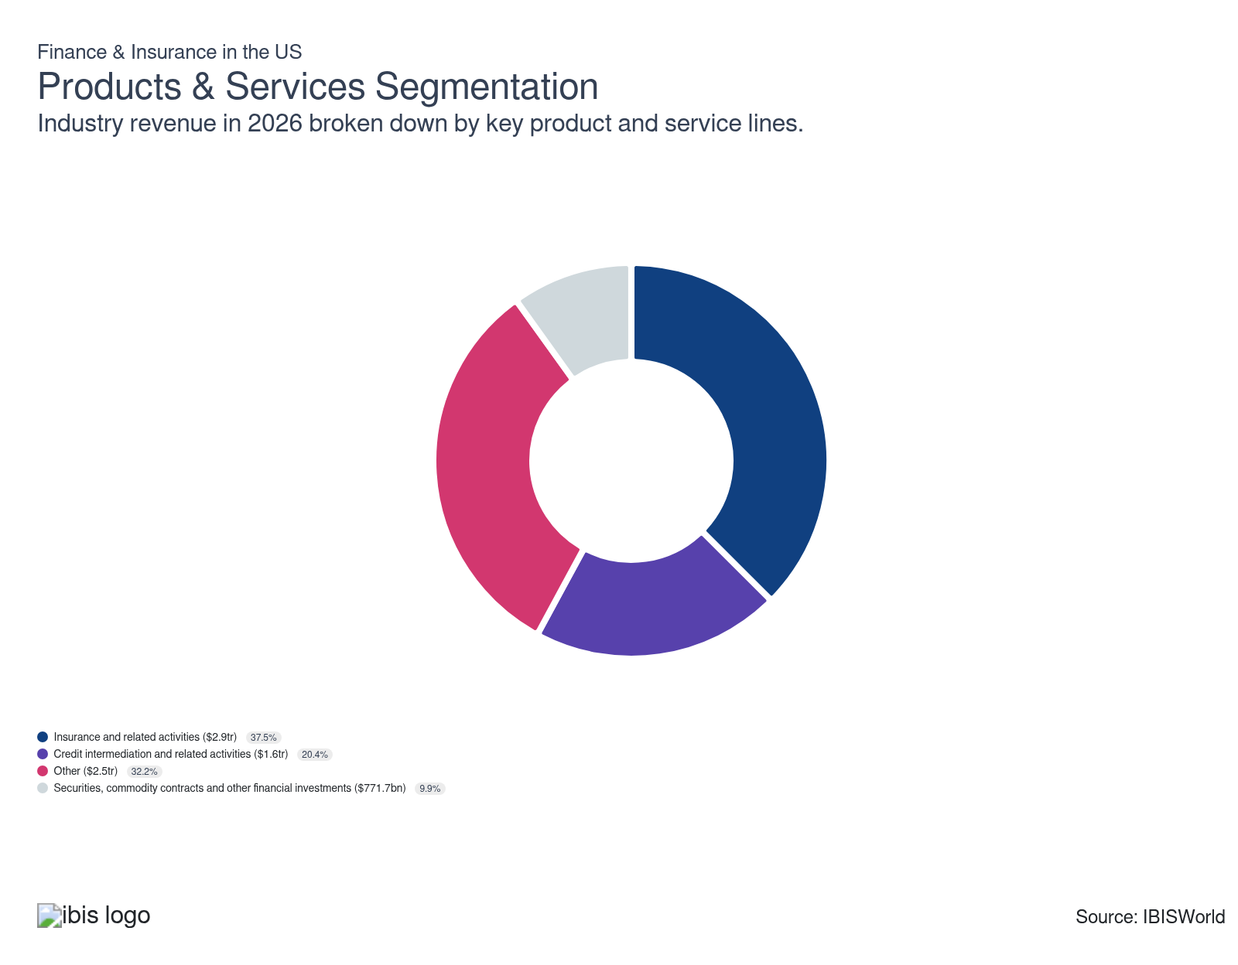

How are the industry’s products and services performing?

The insurance and related activities segment faces relative consistent demand across the business cycle
- Insurance products are essential for managing risks within the economy. The various types of insurance provided by companies in this sector can assist in reducing risk by offering financial compensation. Insurance products provided enable industry companies to create diverse and stable sources of income and attract a broader range of customers my addressing multiple coverage needs.
- Insurance is purchased by consumers and businesses to secure certain benefits in the event of a detrimental occurrence, for example getting seriously ill, getting in a car accident or a family member unexpectedly passing away.
- One area of growth in this segment came from business-related insurance such as general liability insurance and property insurance as the number of businesses grew during the period, boosting demand for this line of insurance. Despite the high-interest-rate environment, business-related insurance products still climbed due to the necessity for businesses to be protected against potential risks.
- The digitization of distribution and servicing, online policy sales, embedded insurance and data-driven risk services, expanded reach and product density, lifting premiums and fee income for insurers. Digital platforms enable the cross-selling of savings, investment and protection products, while risk management services add recurring and fee-based revenue on top of traditional underwriting margins.

Credit intermediation and related activities are essential to the economy
- Access to credit provided by operators in this sector is also critical for the economy to continue to function properly. Operators provide businesses and individuals with financing options for various purchases. These purchases generally cover big-ticket purchases.
- These financing options range from personal loans for consumers to make day-to-day purchases to loans for corporations seeking to expand operations. These types of loans are essential for economic growth. Despite the high interest rate environment which raised borrowing costs, consumers increased demand for personal loans to finance purchases and businesses have demanded commercial loans to expand business operations.
- In the latter part of the period, the Federal Reserve cut interest rates as inflationary pressures cooled. The Fed will monitor economic trends and the impact of the conflict in Iran on energy prices before making future rate cut decisions. Elevated interest rates will deter demand from consumers and businesses for financing services, although interest rate cuts will drive demand for loans and other financial services but limit the interest income earned on these loans.

Securities, commodity contracts and other financial investments are a small but vital segment
- Similar to companies that provide credit intermediation services, operators that provide securities servicing, commodity contracts and other financial investments provide crucial financing and savings services for consumers and businesses. Services provided within this segment include underwriting of debt and equity securities, securities brokering services and various investment activities. These securities make up the main type of investment assets.
- Bonds are the most popular debt instrument traded in this industry. Bonds are low-risk assets, whether government-issued or corporate, that guarantee a fixed return. This segment has increased in size in recent years as interest rates climbed. However, the recent rate cuts in the latter part of the period will reduce demand for fixed-income securities and hinder demand for bond trading.
- Mutual funds are the fruit baskets of the investment world. Various assets, such as equities and bonds, are sold in pieces to investors who don't want to actively manage their portfolios. The popularity of mutual funds is growing in tandem with the size of retail investors.

What are innovations in industry products and services?

Innovation opportunity lies in the digitalization of services
- Since the Great Recession, there has been little change in finance and insurance products. Strict regulations have restricted the extent of innovation that companies can realistically incorporate when developing new product lines.
- Technological advancements and the overall digitalization of the industry in terms of service delivery and process improvements represent the biggest source of innovation for the Finance and Insurance industry in the US.
- Blockchain technology enhances transparency and security by providing immutable transaction records, while artificial intelligence streamlines operations through data-driven insights and automation. Together, they improve efficiency, reduce fraud and personalize services, leading to more innovative and customer-centric products in the sector.

Technological improvement strengthens efficiency of loan lending
- The advancement of new technology, including proprietary smartphone apps, enhances access to loans and bolsters client service for institutions aiming to maintain a consistent line of communication. Also, these smartphone apps and online platforms offer convenience to individuals and businesses.
- Because the product stream relies on financial instruments and there are limited innovative aspects to the loans themselves, most innovation is concentrated on the back-end processes.

What products or services do successful businesses offer?
Manage a high-quality assets portfolio
Asset management is very important for the Finance and Insurance sector. Businesses in this sector must take into account a variety of factors when making investments; namely, liquidity, asset risk and anticipated claims.
Quickly adopt new technology
The main form of innovation of products in this sector is related to updates in technology. Successful businesses in this sector are able to quickly adopt new technologies in addition to being agile enough to incorporate associated improvements and advancements.

Major Markets
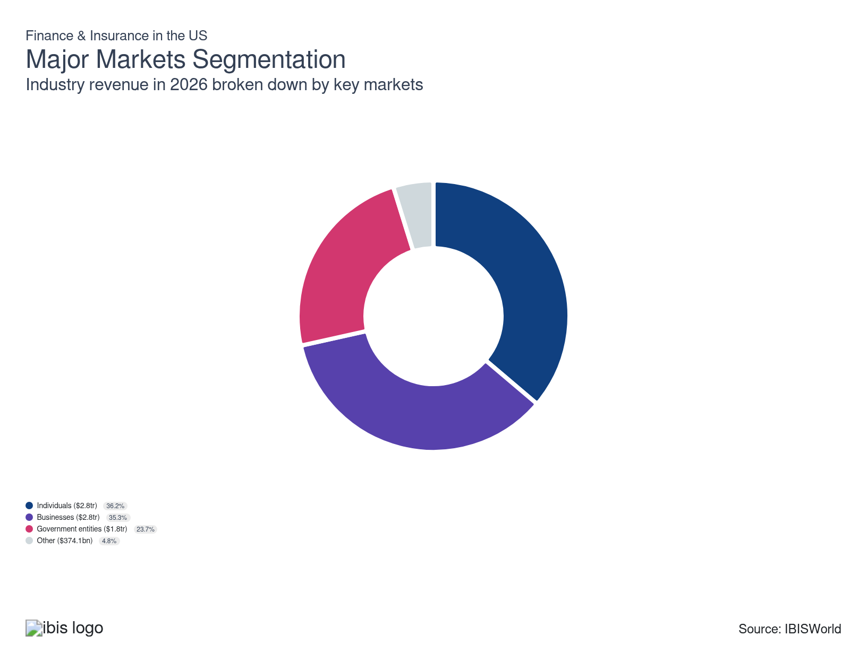

What’s influencing demand from the industry’s markets?

Individual customers comprise the biggest market
- The individual market is the largest in the finance and insurance sector and accounts for over one-third of industry revenue in the current year. Individuals have diverse financial needs, including financial investments, loans and various types of insurance, driving this market's share of revenue.
- Companies in the sector provide consumers with debit and credit cards to make purchases and the banking and depository services they need on a daily basis. Finance and insurance companies also provide individuals with mortgages to purchase homes and financing to purchase large-ticket items such as vehicles.
- Once individuals have made these purchases, they seek out insurance products provided by other companies in the sector. So this market helps sustain the other markets and products. The individual's market typically requires multiple lines of insurance products such as vehicle insurance, health insurance and property and casualty insurance.

Businesses require industry services to sustain and grow their operations
- Businesses have similar financial services needs to individual consumers. Businesses require banking services to make and receive payments for goods and services. These transactions must also be validated by payment processors in the sector, supporting this market's share of revenue.
- Businesses seek out banking services to finance their day-to-day operations and potentially expand their operations. Businesses typically purchase various lines of insurance to insure their business and employees. This limits the revenue volatility associated with the business market.
- Businesses account for the second largest market in the sector and comprise over one-third of revenue in the current year. The growth in the number of businesses has given this sector a greater number of potential clients, although the business sentiment index has fallen over the past five years, limiting growth in the market.

Government entities are a stable source of demand
- Government entities require the services of the finance and insurance sector. Government entities have a relatively constant need for banking and depository services provided by operators in the sector. The jump in local and state government investment over the past five years has driven demand for industry services, boosting this market.
- Local and state government investment represents the total value of funds allocated for fixed assets such as structures, equipment and software. Government agencies seek out investment banks to help them underwriting municipal bonds to help finance local projects. In particular, local government rely on these type of assets to fund operations and expand services.
- Local and state governments increasingly use financial and insurance tools to achieve policy goals such as climate resilience, infrastructure development and inclusive finance by leveraging guarantees such as public and private insurance pools. These initiatives channel substantial public funds and risks, expanding demand for project finance and driving demand for this market in the finance and insurance sector.

Other clients maintain a small market size
- Other customers hold a small market share and include clients that are involved in a one-time, niche-type transactional service. Demand from this market tends to be stable and comprises the smallest market in the sector.
- This segment can vary but it also includes loans to farms, loans to and deposits from government institutions and student loan services, retirement services and auto finance. These services address specific needs and enable clients to receive loans and services for their financial needs.

International Trade

Some industries don't directly import or export goods. See reports at the manufacturing level for international trade data on relevant products.

5. Geographic Breakdown
https://my.ibisworld.com/us/en/industry/52/geographic-breakdown

Key Takeaways
- Many of the region's figures are in California due to the size of its population and economy. The quantity of people, businesses and their sizes creates more demand for the finance sector.
- New York state and New York City are home to major corporate headquarters. The biggest financial institutions in this sector are based in New York City and New York state.

Business Locations
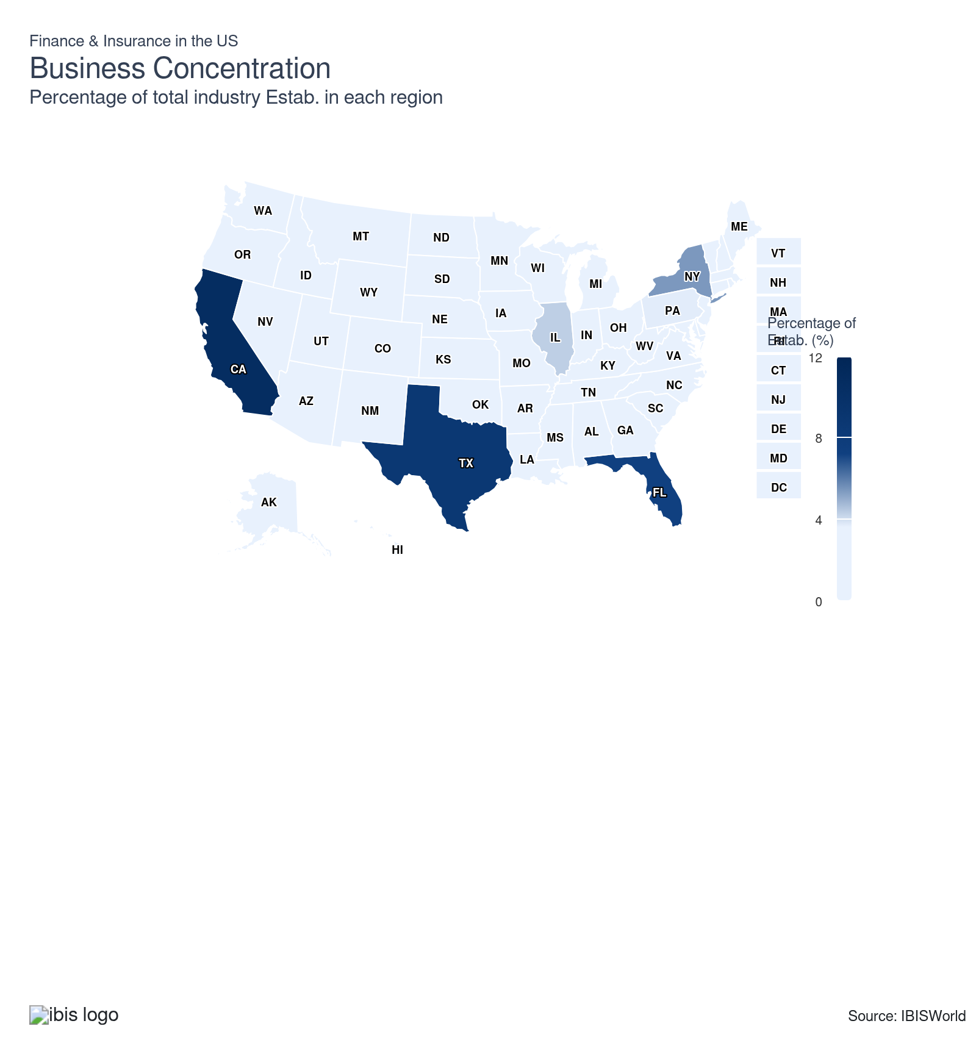
State | Estab.  Units | Estab.  % | Population  %
California | 51548 | 3.8 | 11.5
Texas | 41568 | 3.0 | 9.4
Florida | 34127 | 2.5 | 7.0
New York | 25981 | 1.9 | 5.8
Illinois | 20703 | 1.5 | 3.7
Pennsylvania | 17506 | 1.3 | 3.8
Ohio | 15614 | 1.1 | 3.5
Georgia | 15183 | 1.1 | 3.3
North Carolina | 13597 | 1.0 | 3.3
Michigan | 12719 | 0.9 | 3.0
New Jersey | 11418 | 0.8 | 2.8
Virginia | 11311 | 0.8 | 2.6
Colorado | 10750 | 0.8 | 1.8
Missouri | 10599 | 0.8 | 1.8
Arizona | 9816 | 0.7 | 2.2
Tennessee | 10126 | 0.7 | 2.1
Washington | 9961 | 0.7 | 2.3
Indiana | 9475 | 0.7 | 2.0
Massachusetts | 9597 | 0.7 | 2.1
Minnesota | 9513 | 0.7 | 1.7
Wisconsin | 8775 | 0.6 | 1.7
Alabama | 7360 | 0.5 | 1.5
Louisiana | 7453 | 0.5 | 1.3
Maryland | 7408 | 0.5 | 1.8
South Carolina | 7688 | 0.6 | 1.6
Oklahoma | 6793 | 0.5 | 1.2
Iowa | 6208 | 0.5 | 0.9
Kentucky | 6424 | 0.5 | 1.3
Oregon | 6053 | 0.4 | 1.2
Connecticut | 5737 | 0.4 | 1.1
Kansas | 5926 | 0.4 | 0.9
Utah | 5452 | 0.4 | 1.0
Arkansas | 4555 | 0.3 | 0.9
Mississippi | 4613 | 0.3 | 0.9
Nebraska | 4442 | 0.3 | 0.6
Nevada | 4434 | 0.3 | 1.0
Idaho | 3064 | 0.2 | 0.6
New Mexico | 2636 | 0.2 | 0.6
Delaware | 1999 | 0.1 | 0.3
Maine | 1881 | 0.1 | 0.4
Montana | 1999 | 0.1 | 0.3
New Hampshire | 2076 | 0.2 | 0.4
North Dakota | 1756 | 0.1 | 0.2
South Dakota | 1983 | 0.1 | 0.3
West Virginia | 2052 | 0.1 | 0.5
Hawaii | 1542 | 0.1 | 0.4
Rhode Island | 1504 | 0.1 | 0.3
Alaska | 787 | 0.1 | 0.2
District of Columbia | 1071 | 0.1 | 0.2
Vermont | 914 | 0.1 | 0.2
Wyoming | 1119 | 0.1 | 0.2

Where are industry businesses located?

The Southeast accounts for the highest number of businesses
- The large population of the region increases the retail market for the sector. The high concentration of firms is due to the large population levels in the region. Major cities such as Atlanta, Miami and Charlotte are magnets for regional and national companies seeking cost-effective operations in densely populated areas.
- The Southeast region also hosts many insurance companies as the region is known for having many natural disasters. As a result, insurance premiums are higher in this region compared to other regions across the country. The Southeast's exposure to hurricanes, flood and other extreme weather events necessitates a strong insurance market infrastructure to manage risk.
- Also, this region is known for its favorable regulatory and tax environments which contribute to attracting financial and insurance companies seeking to minimize operational costs. Lower operating costs and attractive tax policies in states like Florida and Georgia have lured company headquarters and major regional offices, enabling these firms to scale up efficiently.

The Mid-Atlantic region hosts many finance and insurance companies
- The Mid-Atlantic has a high concentration of finance and insurance companies in the region due to its large population and it is home to legacy finance and insurance giants, making it a strategic center for complex financial products. In addition, several finance and insurance companies are headquartered in New York, driving the concentration of companies in this region.
- The Mid-Atlantic region is a popular location for companies in this sector due to the strategic location of major economic hubs such as New York and Boston. Affluent urban and suburban populations drive unique demand for innovative products. The region’s population includes high-net-worth individuals and globally connected entrepreneurs, which fosters insurer interest in tailored coverage and complex risk pooling options.
- The region has access to a highly educated and skilled workforce, supported by renowned academic institutions and universities in the region. Also, as state laws and climate models shift, regional insurers are forced to adapt rapidly, leading to innovation cycles to create relevant and profitable coverage.

The West comprises a large concentration of finance and insurance companies
- The West has a large concentration of companies in this sector. California comprises the most industry players in the region, driving concentration in the region. The West is known for having a diverse economy with strong sectors in technology, entertainment and trade which attracts many financial companies to the region.
- The West is also known for having natural disasters and wildfires, which also attracts insurance companies to the region. Due to the threat of wildfires and natural disasters, this region has higher premiums for insurance policies. Flexible insurance markets provide immediate claims service and long-term risk mitigation strategies.
- In addition, large urban centers, especially those in California and Washington, offer high concentrations of skilled technical, actuarial and financial talent. This workforce depth enables companies to stay ahead of national trends, innovate faster and efficiently while also responding nimbly to changes in consumer and regulatory expectations.
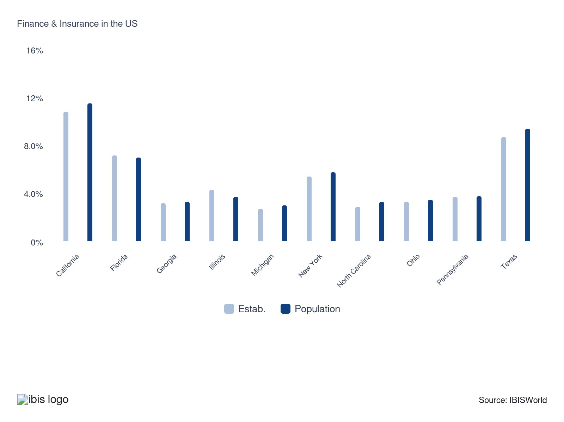

How do businesses use location to their advantage?
Operate in a location that is close to key markets
Proximity to key markets enables finance and insurance firms to better understand client needs, quickly respond to market changes and build strong relationships with major financial institutions.
Ensure skilled labor is available
Access to a skilled workforce is crucial for finance and insurance companies to deliver high-quality services, innovate and maintain competitive operations in a complex and evolving industry.

6. Competitive Forces
https://my.ibisworld.com/us/en/industry/52/competitive-forces

Key Takeaways
- The sector offers a wide array of products and services to downstream consumers, making it difficult for any single operator to control a large portion of the total sector.
- Operators that can improve their technological networks can achieve economies of scale and in turn create lower costs and expand operations more efficiently.

Concentration
Low
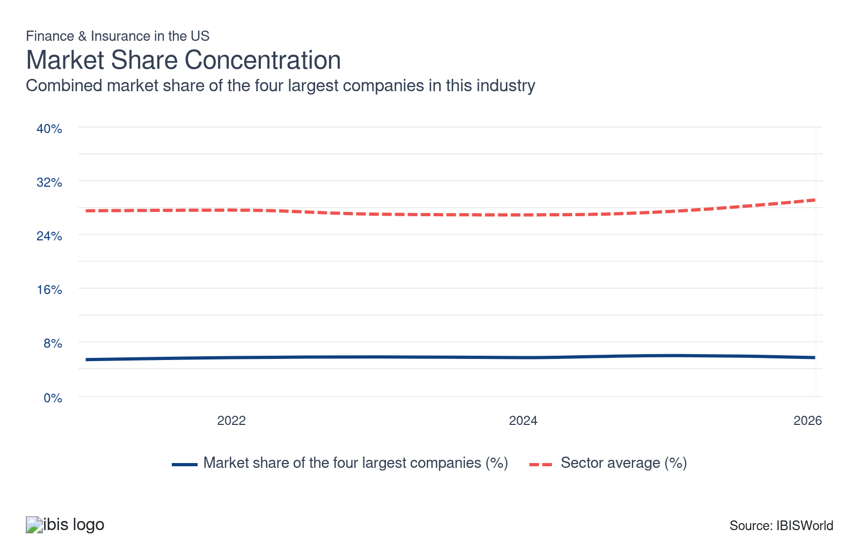

What impacts the industry’s market share concentration?

Various factors impact concentration across the sector
- The sector offers a wide array of products and services to downstream consumers, making it next to impossible for any single operator to control a significant share of the sector. Also, many companies in the sector offer similar products and services, increasing competition and limiting the number of players with significant market share concentration.
- Some industries, such as the Insurance Brokers and Agencies industry (IBISWorld report 52421), display a similarly low level of market share concentration, while others, such as the Health and Medical Insurance industry (52411b), display a moderate level of market share concentration.
- For industries such as the Property, Casualty and Direct Insurance industry (52412), being in proximity to clients is important to gain an in-depth understanding of their insurance needs and help tailor insurance products to those needs.

The industry is growing and no major player dominates the sector
- The industry expanded over the past five years, attracting new entrants. As a result, the number of industry establishments climbed. Since products and services are similar in this sector, new entrants compete on the basis of price and customer service to establish a presence.
- UnitedHealth Group Incorporated is the largest player in the industry, although the company does not comprise over 5.0% of industry revenue. The industry is very competitive, which limits one player from dominating the industry.

How do successful businesses handle concentration?
Degree of globalization in the firm
Major players need to be pursuing a regional or global strategy. A strong brand name and reputation is important in attracting and retaining customers.
Develop a strong reputation
Building a strong reputation fosters trust and loyalty among clients, essential for standing out in the industry which is a concentrated market and helps to attract a stable customer base.

Barriers to Entry
Moderate | Steady

What challenges do potential industry entrants face?

Legal
- Most industries in this sector face stringent regulations, resulting in substantial legal fees for newcomers. Companies must adhere to capital and regulatory requirements, which add to their overall costs. This challenges new entrants as companies must strategically plan to navigate the sector's complex regulatory landscape.

Start-up Costs
- Start-up costs differ, yet most industries in this sector encounter high initial expenses and must secure affordable funding. New entrants must build a strong reputation which is crucial to attracting a large customer base and ensuring profitability, all while maintaining competitive rates.

Differentiation
- In this sector, most industries must stand out through their rates and customer service. In addition, new entrants seek to achieve economies of scale to offer competitive pricing alongside established companies, ensuring a strong foothold in this competitive market landscape. Companies broaden their service offerings and geographical reach to better reach customers.

Labor Expenses
- Most industries in this sector are labor-intensive. Highly skilled and educated workers continue to be integral to most industries in the sector since many services require either advanced knowledge in finance or technology. In addition, highly skilled workers are required to build relationships with customers and retain clients.

How can potential entrants overcome barriers to entry?
Well-developed internal processes
To achieve success in the finance and insurance sector, it's vital to implement strong prudential guidelines and controls. Establish clear guidelines and develop comprehensive internal processes to ensure optimal performance.
Ability to effectively manage risk
Strong portfolio management skills are necessary, such as a certain level of exposure consistent with size and risk of each of the industries comprising the economy.

Substitutes
Low | Steady

What are substitutes for industry services?

Substitutes are limited
- Heavy regulation limits the ability for non-Finance and Insurance industries to provide financial or insurance services to retail and business clients. These policies maintain market stability and consumer protection but create high entry barriers, discouraging nonfinancial firms from competing.
- In addition, substitutes are limited due to industry players requiring an abundance of funds to operate in the industry. This acts as a barrier to entry and protects existing operators from new entrants.

How do successful businesses compete with substitutes?
Produce a differentiated product
Creating unique and tailored products helps companies stand out, reducing the risk of clients opting for substitute alternatives and strengthening market position.
Develop a loyal customer base
Fostering loyalty ensures repeat business and enhances resilience against substitutes, as satisfied customers are less likely to switch providers.

Buyer & Supplier Power
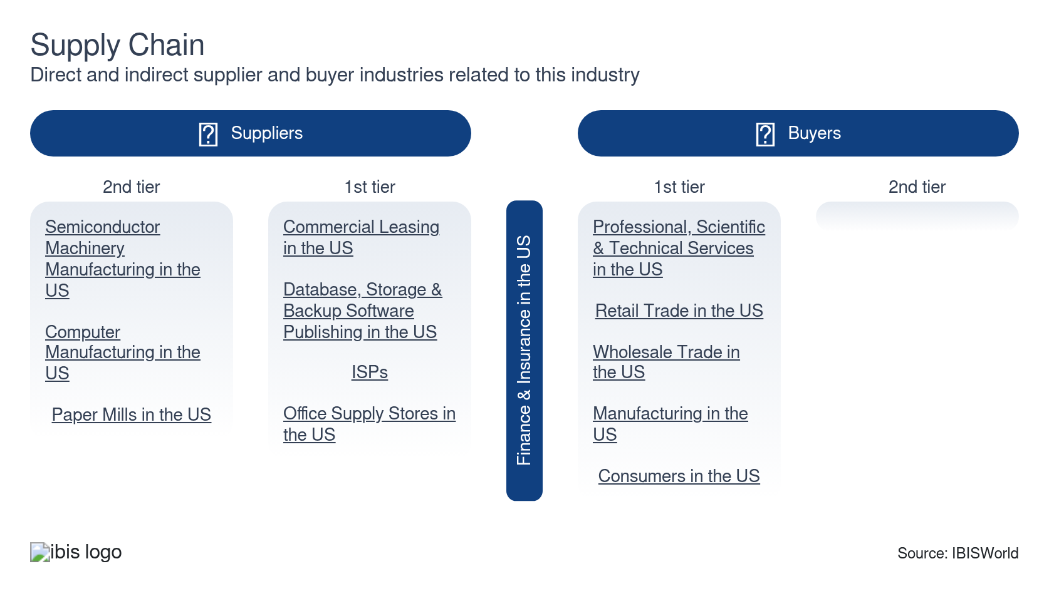

What power do buyers and suppliers have over the industry?

Buyers: Costs and convenience
High | Increasing
- Buyers choose services in this sector that are affordable and convenient. Buyers also seek to choose services that are reliable and have a solid reputation. Since products and services are very similar in this sector, competition on the basis of price is significant.
- Companies that provide convenience enable buyers to save time and effort, whether it's through easily accessible digital platforms, streamlined processes or responsive customer service. Cost is also a crucial consideration as it can impact a buyer's budget and long-term financial commitments.
- A business client will take out a loan from a commercial bank that charges less interest over time. Buyers will select securities brokerage companies with the best user experience. Mobile and digital platforms have enhanced accessibility and satisfaction for customers.

Suppliers: Energy costs, regulation and advanced technology systems
High | Increasing
- Most of the industries in this sector are digitizing their services, which require fast and reliable technological networks. This transformation demands fast, secure and scalable technology infrastructures. Finance and insurance companies have increasingly invested in AI-driven analytics and data networks to support real time transactions.
- Government regulations dictate a lot of the supply requirements and costs in this sector. Strict capital requirements, solvency mandates and tax obligations represent significant external costs that finance and insurance companies continuously monitor and integrate into financial planning.
- Advanced technology systems have helped improve accuracy by minimizing errors with precise data handling and comprehensive analytics. In addition, these technology systems also reduce costs and can help to provide robust security measures to protect sensitive financial information and provide protection against cyber threats.

How do successful businesses manage buyer & supplier power?
Automation - reduces costs, particularly those associated with labor
Successful companies must invest in information and telecommunication technology to reduce processing and labor costs.
Provide services to groups with high disposable income
Targeting affluent groups by delivering top-notch services and products helps to enhance revenue. This helps to reduce buyer power and builds a loyal customer base.

7. Companies
https://my.ibisworld.com/us/en/industry/52/companies

Key Takeaways
- Major companies are adapting to higher interest rates and less liquidity. After nearly 15 years of quantities easing, the Federal Reserve is reducing its balance sheet to help control inflation.
- Environmental, social and governance (ESG) is increasing in importance for both investors and businesses. Companies are creating a more inclusive and diverse working environment.

Market Share
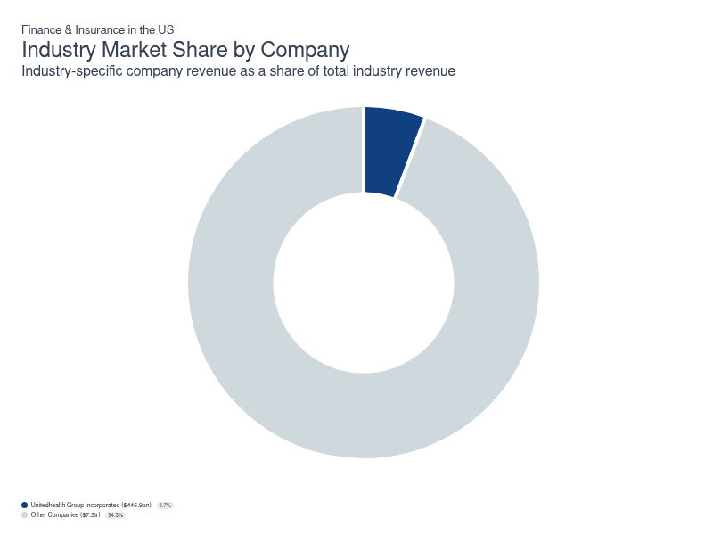
Chart displays current year only in the PDF version of this report. You can view and download chart for all other years associated with this industry on my.ibisworld.com.

Companies
Company | Market Share (%)  2026 | Revenue ($m)  2026 | Profit ($m)  2026 | Profit Margin (%)  2026
Unitedhealth Group Incorporated | 5.7 | 446,900.5 | 23,300.8 | 5.2

Unitedhealth Group Incorporated
Unitedhealth Group Incorporated
Company Details
Company Details
Industry Specific Revenue (2026) | $446.9bn
Industry Profit (2026) | $23.3bn
Company Employees (2026) | 400,000
Market Share (2026) | 5.7%

Description
Description
Unitedhealth is a public company headquartered in Minnesota with an estimated 400,000 employees. In the US, the company has a notable market share in at least six industries: Finance & Insurance, Health & Medical Insurance, Pharmacy Benefit Management, Healthcare Consulting, Vision Insurance, HMO Providers and Finance & Insurance. Their largest market share is in the Healthcare Consulting industry, where they account for an estimated 34.0% of total industry revenue.

Brands and Trading Names
Brands and Trading Names
- Optum
- Optum Health
- Optum Insight
- Optum Rx
- UnitedHealthcare

Other Industries
Other Industries
- Health & Medical Insurance in the US
- Healthcare Consulting in the US
- HMO Providers in the US
- Pharmacy Benefit Management in the US
- Vision Insurance in the US

Company’s Industry Revenue, Market Share, and Profit Margin Over Time
Company’s Industry Revenue, Market Share, and Profit Margin Over Time
Year | Industry Revenue ($ million) | Market Share (%) | Profit Margin (%)
2020 | 257141 | 5.1 | 8.1
2021 | 287597 | 5.4 | 7.8
2022 | 324162 | 5.7 | 8.1
2023 | 371622 | 5.8 | 7.8
2024 | 400278 | 5.7 | 5.0
2025 | 446901 | 6.0 | 5.2
2026 | 446901 | 5.7 | 5.2

You can view and download company details on my.ibisworld.com.

8. External Environment
https://my.ibisworld.com/us/en/industry/52/external-environment

Key Takeaways
- Regulation is still heavily influenced by the Great Recession. The government wants to ensure financial crises don’t occur and protect consumers.
- The Finance and Insurance sector only receives direct assistance in financial emergencies. The last time the industry received big direct government assistance was in the great financial crisis.

External Drivers

What demographic and macroeconomic factors impact the industry?
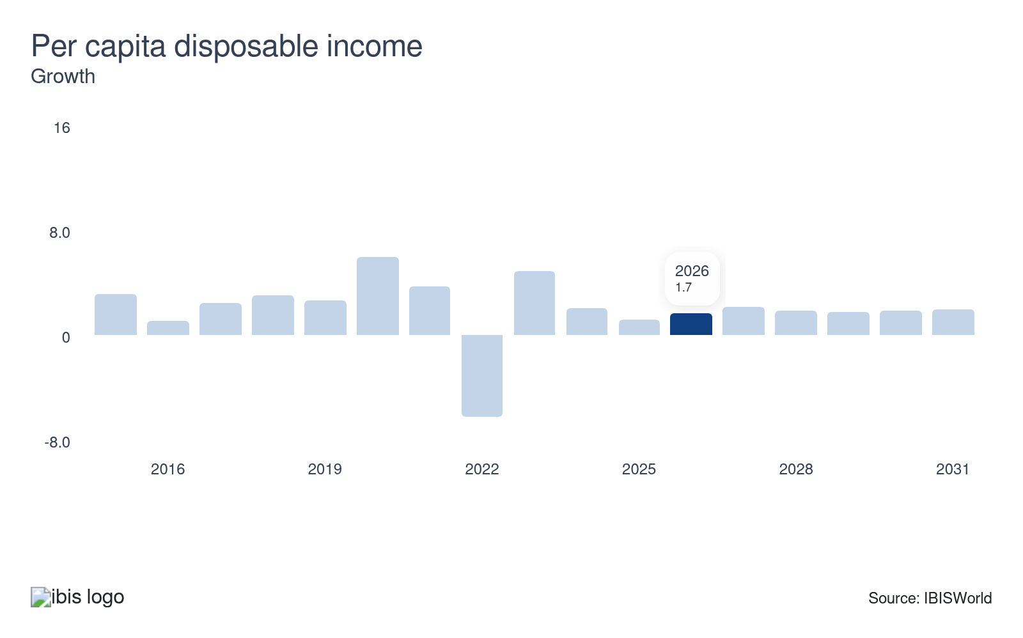
As per capita disposable income levels rise, consumer long-term financial security increases. When this occurs, consumers are more likely to use a wide variety of services provided by operators in this sector. Growth in per capita disposable income represents a potential opportunity for the sector.
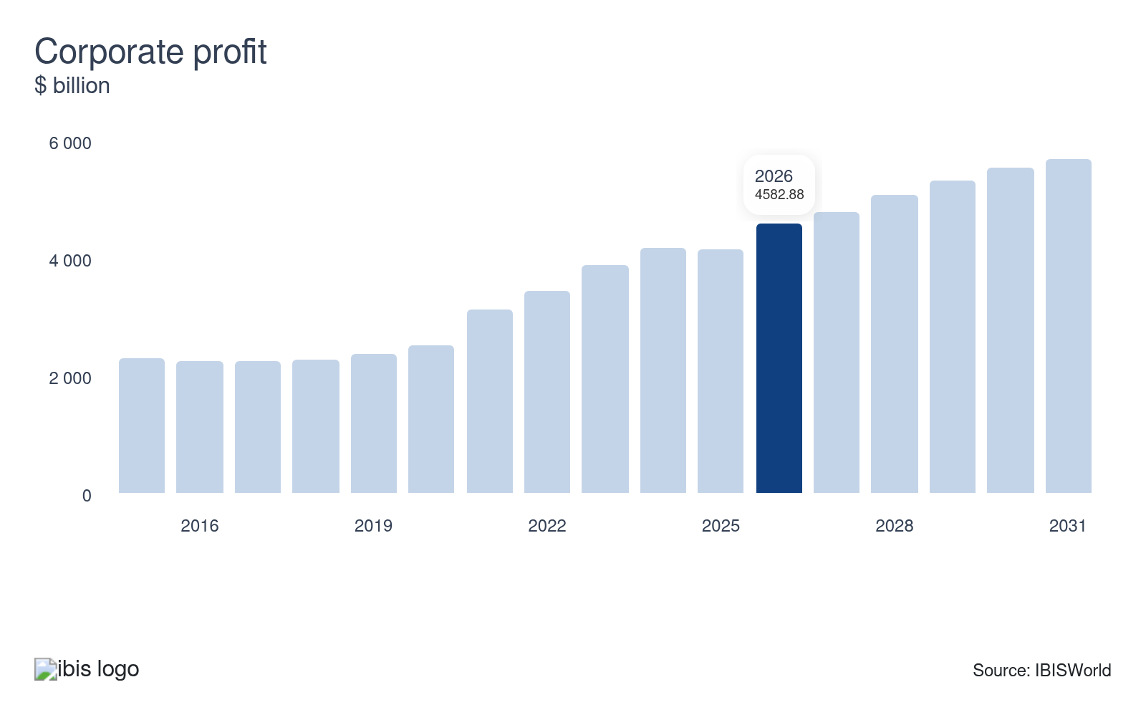
Increasing corporate profit levels also benefits operators in this sector. As business operations become more profitable, operators are more likely to undertake new projects to expand their businesses that require the services of operators in this sector. This materializes in the form of increased demand for operators’ services. Growth in corporate profit will enable operators to undertake new projects and expand their business and increase demand for industry services.
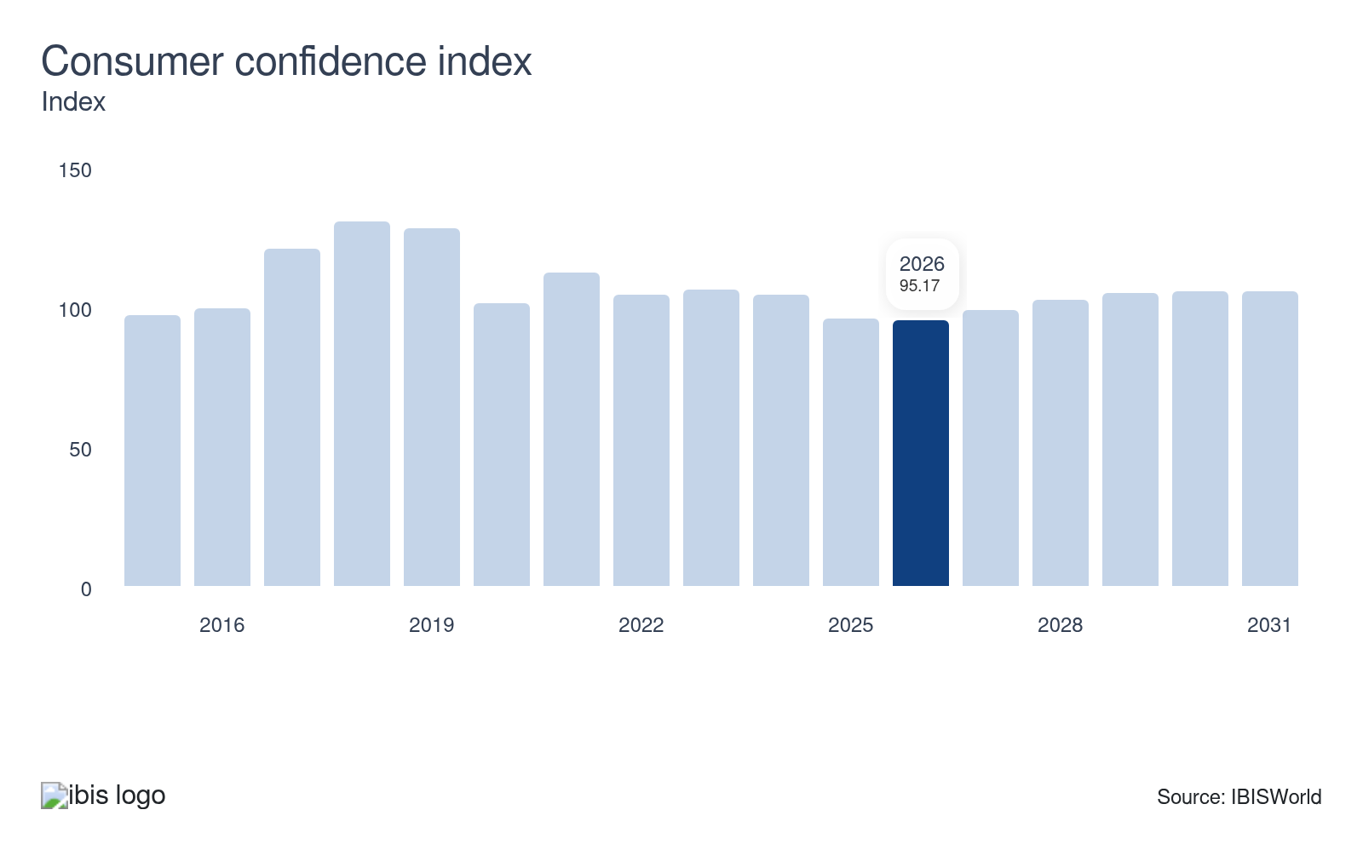
As consumers’ confidence in the economy increases, their overall level of consumption tends to increase. Operators in this sector benefit from increased consumption levels by consumers, as they provide a variety of services that consumers need to make transactions. Declines in the Consumer Confidence Index poses a potential threat to the sector.
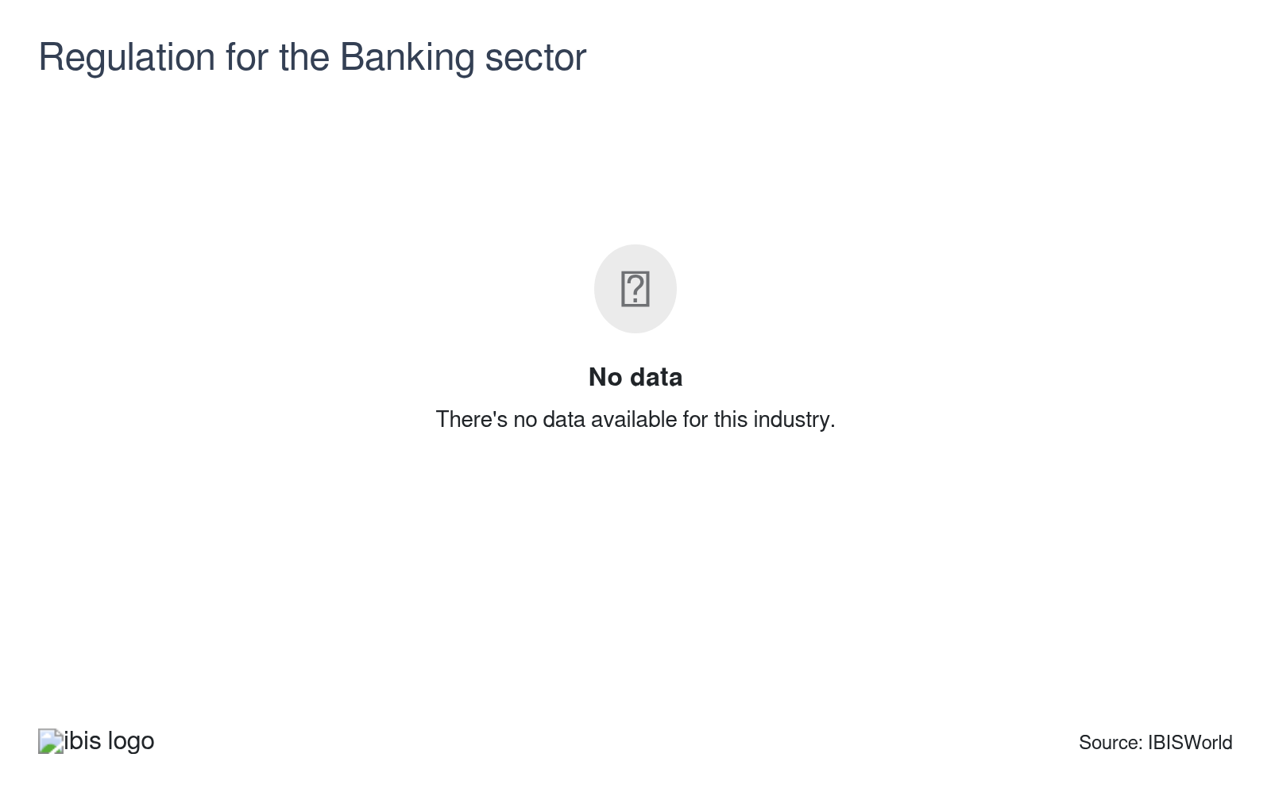
The Banking sector is one of the largest components of the larger Finance and Insurance sector. The Banking sector in particular is one of the most regulated sectors in the economy, and has been since the 1930s. In recent years, regulation of the Banking sector has increased, which has materially affected banks’ profitability. Growth in regulation will increase costs for the sector.

Regulation & Policy
High | Steady

What regulations impact the industry?

2010 Dodd-Frank Wall Street Reform and Consumer Protection Act
The 2010 Dodd-Frank Wall Street Reform and Consumer Protection Act marked a pivotal change for the sector, enacted in response to the subprime mortgage crisis. This law significantly altered banking operations, especially for investment banks, by restricting their activities and consequently limiting profitability. The primary goal was to create a more stable banking environment, reducing the risk of systemic failure if another financial crisis were to occur.

Basel III
Basel III is an international regulatory standard that was passed at the beginning of the period. The law was passed to set uniform liquidity and bank capital requirements for banking institutions that operate globally. The hope of the law was to prevent against many of the issues that led to the wider global financial crisis that occurred prior to the period. The primary goal was to increase the liquidity of banks' balance sheets, to assure that there were higher reserves on hand to pay down unprofitable investments and ensure greater financial stability.

Assistance
Low | Steady

What assistance is available to this industry?

The Troubled Asset Relief Program
In response to the 2008 financial crisis, the government enacted the Troubled Asset Relief Program (TARP) to repurchase toxic mortgage loans and other investments on banks' and other financial institutions' balance sheets, using funds set aside by the federal government. TARP helped stabilize the Finance and Insurance sector as the economy faced its worst crisis since the Great Depression. In addition, TARP was also crucial in restoring confidence in financial markets.

Private support doesn't apply to the industry
The Finance and Insurance sector does not receive any private assistance.

9. Financial Benchmarks
https://my.ibisworld.com/us/en/industry/52/financial-benchmarks
Profit Margin  28.8 %  ↑ Higher than sector | Average Wage  $122k  ↓ Lower than sector | Largest Cost  Wages  13.5% of Revenue

Key Takeaways
- The Federal Reserve increased interest rates to control inflation. As inflationary pressures eased, the Federal Reserve cut interest rates in the latter part of the current period.
- Most companies require well-trained, knowledgeable staff that can provide excellent customer service, manage risk, perform advisory services to clients and perform competent underwriting for loans and other credit products, such as credit cards.

Cost Structure
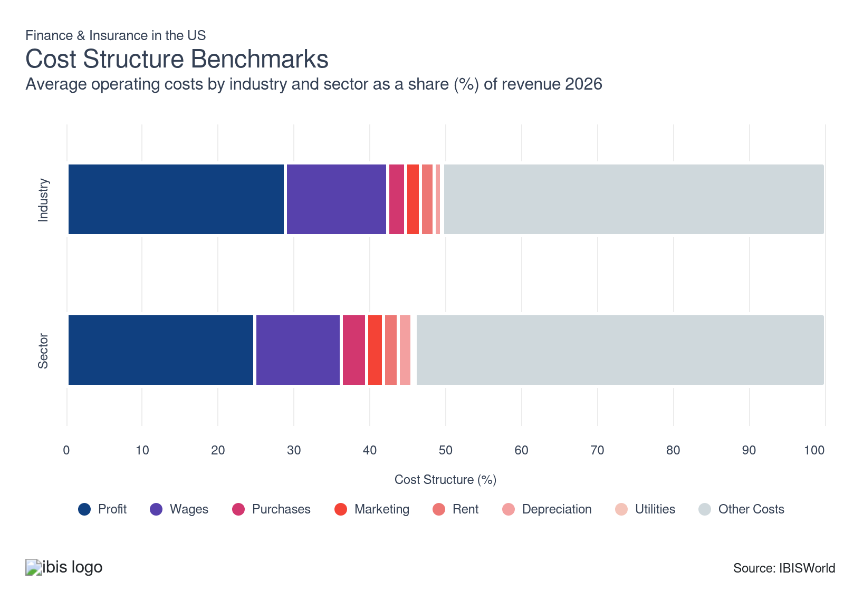
Chart displays current year only in the PDF version of this report. You can view and download chart for all other years associated with this industry on my.ibisworld.com.

What trends impact industry costs?

Profit grows amid the high interest rate environment
- Profit climbed despite the turbulent macroeconomic climate. From the potential risk of recession and near-zero interest rates inflating asset prices at the onset of the period. In addition, supply chain issues encountered in the global economy and rampant inflation with very high interest rates in the latter part of the period have caused uncertainty and volatility in the sector.
- Profit, defined as earnings before interest and taxes, is anticipated to account for over one-quarter of industry revenue in the current year and has climbed over the past five years due to growth in investment income from fixed income securities and greater interest income from loans.
- The Federal Reserve increased interest rates to control inflation. This had mixed results for the various industries in this sector. Higher interest rates result in higher interest income for companies that issue loans. But, if rates get too high, demand for debt will decline. However, despite rates being high during the current period, loan demand climbed as individuals navigated the high-interest-rate environment.
- In the latter part of the period, as inflationary pressures cooled, the Fed cut interest rates, boosting demand for loans but hindering interest income. The Fed will continue to monitor economic trends and the impact of the conflict in Iran on energy markets, impacting future interest rate decisions.

The need for skilled workers maintains significant wage expenses
- Wages, as a share of revenue, declined over the past five years due to the growing use of technological tools such as AI and financial modeling tools, helping to assess potential investment risks, which maximizes returns. However, wages remain the single largest industry expense due to demand for skilled employees, maintaining elevated wage costs for the sector.
- Wages are high in most of the sector's industries due to their service-based nature and the necessity for highly educated employees. Most companies require well-trained, knowledgeable staff that can provide excellent customer service, manage risk, provide advisory services to clients and competently underwrite loans and other credit products, such as credit cards.

Purchase costs lag and are limited across the sector
- Purchase costs fell during the period and are expected to account for a minimal share of revenue in the current year. Purchase costs are limited across the sector, which limits purchase cost expenses.
- As a service-based sector, Finance and Insurance operators require few purchases to function on a day-to-day basis. Purchase costs include technology infrastructure such as computers, servers, office supplies and equipment like printers and scanners.
- Purchase costs for this sector are minimal and limited. In addition to computers and hardware, this sector's purchases include data storage and backup systems such as hard drives, cloud storage solutions and backup systems which are crucial purchases to secure important data.

Miscellaneous costs fall but remain a significant expense
- Miscellaneous costs include various costs such as regulatory costs. Miscellaneous costs comprise over one-half of industry revenue in the current year. The most significant miscellaneous costs for the sector include regulatory expenses. The sector is highly regulated specifically following the Great Recession prior to the current period.
- In addition, companies in the sector pay for legal and regulatory consultants to help navigate complex compliance requirements. Also, penalties and fines can be substantial for companies that fail to meet regulatory requirements.

Rent costs are steady and comprise office space expenses
- Finance and insurance companies rent office space to have an area where employees can effectively sell providers' products, services and offer customer service help. Also, companies in the sector process claims, engage in actuarial work, manage reserves and review legal documents to ensure compliance with regulations.
- Rent expenses can fluctuate for each industry companies on various factors. For example, companies with larger office spaces in urban metro areas will generally encounter greater rent expenses compared to smaller companies in urban locations.

Marketing costs lag despite the prevalence of individual customers
- Finance and insurance companies sell to many individual customers since they offer various financial products and services. Since most individuals don't know all of the players in this industry due to low market share concentration, companies typically benefit from advertising.
- Marketing expenses fell slightly despite companies engaging in traditional advertising methods such as newspapers, articles and magazines while also increasingly using digital advertising channels like social media platforms and online platforms. Other industry costs have climbed at a greater rate, causing marketing costs to fall as a share of revenue.

Depreciation expenses are relativelty steady
- Finance and insurance companies invest in various technologies to streamline operations, such as policy administration systems (these are platforms that handle policy issues, management, billing and claims), underwriting and risk assessment systems, customer relationship management (CRM) software, fraud detection systems, computers and other essential materials.
- Depreciation costs can fluctuate widely due to new technologies, including computers, printers and other office equipment, which have various useful lives and are depreciated accordingly. Although some firms in the sector generally require fast and updated technology for daily operations.

Utility costs generally track with rental costs
- When paying rent, companies must also satisfy utility bills such as water, heat, electricity and cooking gas. Utility expenses are very low in this industry since employees engage in very benign activities, such as turning lights on and printing that don't raise bills much. More broadly, this segment moves in line with rental expenses since when providers open up new office space, they incur new utility costs.
- Utility costs remained relatively steady and account for the single smallest expense in the industry. Similar to rent expenses, utility costs can vary based on the size of the office and the utilities being used and the location of the office.
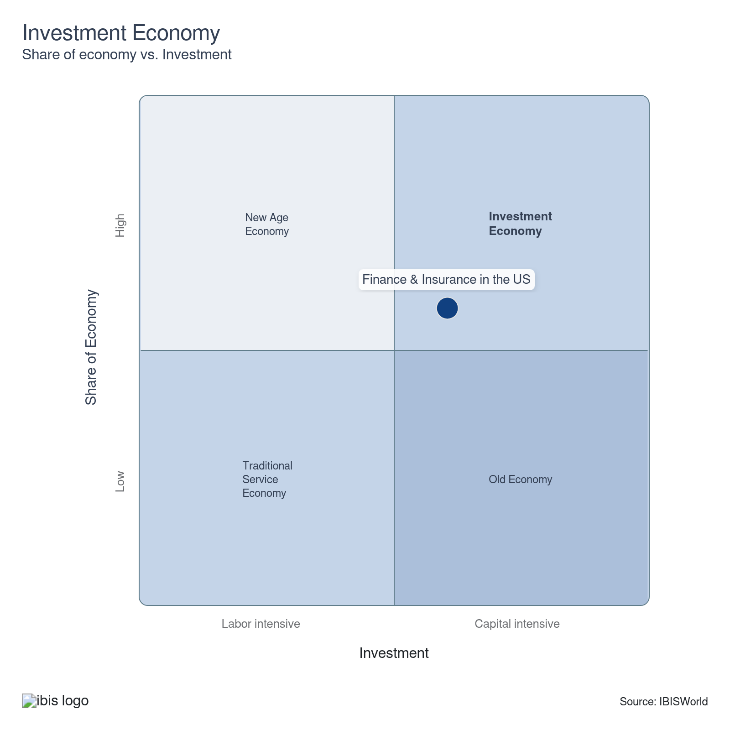

Key Ratios
Year | Revenue per Employee  ($) | Revenue per Enterprise  ($ Million) | Employees per Estab.  (Units) | Employees per Enterprise  (Units) | Average Wage  ($) | Wages/ Revenue  (%) | Estab. per Enterprise  (Units) | IVA/ Revenue  (%)
2002 | 691,642 | 5.4 | 6.4 | 7.9 | 92,331 | 13.3 | 1.2 | 35.2
2003 | 695,279 | 5.3 | 6.2 | 7.6 | 94,396 | 13.6 | 1.2 | 36.9
2004 | 710,590 | 5.3 | 6.1 | 7.4 | 98,117 | 13.8 | 1.2 | 35.3
2005 | 719,154 | 5.1 | 5.9 | 7.2 | 100,989 | 14.0 | 1.2 | 33.5
2006 | 716,051 | 5.2 | 5.9 | 7.3 | 102,264 | 14.3 | 1.2 | 43.6
2007 | 736,698 | 5.2 | 5.8 | 7.1 | 107,003 | 14.5 | 1.2 | 47.5
2008 | 735,888 | 5.4 | 5.9 | 7.3 | 108,436 | 14.7 | 1.3 | 47.6
2009 | 762,135 | 5.4 | 5.6 | 7.1 | 99,620 | 13.1 | 1.3 | 37.1
2010 | 775,861 | 5.4 | 5.6 | 7.0 | 104,846 | 13.5 | 1.2 | 38.4
2011 | 769,962 | 5.4 | 5.6 | 7.0 | 108,050 | 14.0 | 1.2 | 39.1
2012 | 769,861 | 5.4 | 5.6 | 7.0 | 110,470 | 14.3 | 1.3 | 40.8
2013 | 762,309 | 5.5 | 5.7 | 7.2 | 110,739 | 14.5 | 1.3 | 41.6
2014 | 785,628 | 5.6 | 5.7 | 7.1 | 114,402 | 14.6 | 1.2 | 41.4
2015 | 795,675 | 5.7 | 5.8 | 7.2 | 118,005 | 14.8 | 1.2 | 40.9
2016 | 790,590 | 5.8 | 5.9 | 7.4 | 116,558 | 14.7 | 1.3 | 41.8
2017 | 802,777 | 5.9 | 5.9 | 7.4 | 119,071 | 14.8 | 1.2 | 41.7
2018 | 821,540 | 6.0 | 5.9 | 7.3 | 119,900 | 14.6 | 1.2 | 42.4
2019 | 844,179 | 6.2 | 5.9 | 7.4 | 121,386 | 14.4 | 1.2 | 42.6
2020 | 839,654 | 6.3 | 6.0 | 7.4 | 126,994 | 15.1 | 1.2 | 41.9
2021 | 847,184 | 6.3 | 6.0 | 7.5 | 132,046 | 15.6 | 1.2 | 41.6
2022 | 830,351 | 6.2 | 6.0 | 7.4 | 124,272 | 15.0 | 1.2 | 41.9
2023 | 879,506 | 6.6 | 6.1 | 7.5 | 121,295 | 13.8 | 1.2 | 42.9
2024 | 893,218 | 6.8 | 6.2 | 7.7 | 121,676 | 13.6 | 1.2 | 43.1
2025 | 901,998 | 7.0 | 6.3 | 7.7 | 121,915 | 13.5 | 1.2 | 43.3
2026 | 902,058 | 7.0 | 6.3 | 7.8 | 121,914 | 13.5 | 1.2 | 43.3
2027 | 902,054 | 7.0 | 6.3 | 7.8 | 121,914 | 13.5 | 1.2 | 43.3
2028 | 901,657 | 7.1 | 6.3 | 7.8 | 121,903 | 13.5 | 1.2 | 43.3
2029 | 900,470 | 7.1 | 6.3 | 7.8 | 121,871 | 13.5 | 1.2 | 43.3
2030 | 899,372 | 7.1 | 6.4 | 7.8 | 121,841 | 13.5 | 1.2 | 43.2
2031 | 898,451 | 7.1 | 6.4 | 7.9 | 121,816 | 13.6 | 1.2 | 43.2
2032 | 880,735 | 6.8 | 6.3 | 7.7 | 121,336 | 13.8 | 1.2 | 43.0
*Figures are inflation adjusted to 2026
*Figures are inflation adjusted to 2026

10. Key Statistics
https://my.ibisworld.com/us/en/industry/52/key-statistics

Industry Data

Values
Year | Revenue  ($ Million) | IVA  ($ Million) | Estab.  (Units) | Enterprises  (Units) | Employment  (Units) | Wages  ($ Million)
2002 | 4,893,283.2 | 1,721,042.6 | 1,110,714 | 898,175 | 7,074,875 | 653,233.3
2003 | 4,977,262.5 | 1,836,689.3 | 1,155,544 | 939,610 | 7,158,659 | 675,750.7
2004 | 5,115,424.9 | 1,804,998.2 | 1,188,166 | 969,504 | 7,198,843 | 706,327.0
2005 | 5,159,038.4 | 1,729,648.6 | 1,218,734 | 1,001,911 | 7,173,765 | 724,470.9
2006 | 5,302,545.7 | 2,312,505.8 | 1,252,496 | 1,021,195 | 7,405,265 | 757,294.2
2007 | 5,387,024.0 | 2,558,687.1 | 1,271,618 | 1,027,720 | 7,312,395 | 782,451.1
2008 | 5,331,597.3 | 2,540,423.7 | 1,235,411 | 986,892 | 7,245,120 | 785,629.0
2009 | 5,262,472.3 | 1,951,235.3 | 1,222,578 | 976,115 | 6,904,909 | 687,869.5
2010 | 5,155,990.5 | 1,980,596.7 | 1,190,310 | 954,730 | 6,645,511 | 696,755.2
2011 | 5,082,001.0 | 1,988,749.3 | 1,181,264 | 947,290 | 6,600,329 | 713,167.0
2012 | 5,158,268.4 | 2,107,115.7 | 1,195,108 | 955,439 | 6,700,259 | 740,174.5
2013 | 5,160,947.6 | 2,148,339.8 | 1,178,636 | 941,233 | 6,770,155 | 749,723.0
2014 | 5,337,935.4 | 2,207,865.5 | 1,186,718 | 951,803 | 6,794,480 | 777,298.8
2015 | 5,453,861.8 | 2,232,310.6 | 1,188,534 | 955,880 | 6,854,386 | 808,852.7
2016 | 5,576,496.0 | 2,333,382.2 | 1,193,776 | 954,764 | 7,053,586 | 822,151.8
2017 | 5,732,121.5 | 2,392,148.2 | 1,210,420 | 970,604 | 7,140,364 | 850,207.5
2018 | 5,959,911.3 | 2,526,680.0 | 1,232,915 | 994,633 | 7,254,561 | 869,824.7
2019 | 6,169,668.8 | 2,627,579.8 | 1,232,007 | 993,588 | 7,308,486 | 887,149.1
2020 | 6,247,517.7 | 2,618,080.1 | 1,235,055 | 999,229 | 7,440,582 | 944,907.0
2021 | 6,353,201.9 | 2,639,937.4 | 1,239,779 | 1,006,245 | 7,499,197 | 990,235.5
2022 | 6,322,720.0 | 2,649,572.2 | 1,263,164 | 1,027,154 | 7,614,515 | 946,273.7
2023 | 6,857,678.2 | 2,944,519.6 | 1,274,949 | 1,036,844 | 7,797,190 | 945,757.6
2024 | 7,293,328.2 | 3,146,719.6 | 1,314,574 | 1,067,079 | 8,165,227 | 993,509.4
2025 | 7,646,951.1 | 3,309,808.5 | 1,349,466 | 1,094,029 | 8,477,792 | 1,033,574.1
2026 | 7,794,605.6 | 3,373,648.7 | 1,370,476 | 1,110,864 | 8,640,913 | 1,053,446.6
2027 | 7,957,788.2 | 3,444,076.2 | 1,394,602 | 1,130,253 | 8,821,857 | 1,075,505.1
2028 | 8,121,837.5 | 3,514,393.8 | 1,420,783 | 1,151,360 | 9,007,679 | 1,098,062.7
2029 | 8,282,607.3 | 3,582,481.0 | 1,448,809 | 1,174,039 | 9,198,092 | 1,120,979.5
2030 | 8,453,744.0 | 3,655,281.6 | 1,477,998 | 1,197,593 | 9,399,606 | 1,145,258.8
2031 | 8,636,986.7 | 3,733,546.1 | 1,509,745 | 1,223,237 | 9,613,199 | 1,171,043.2
2032 | 8,306,994.6 | 3,572,193.9 | 1,504,768 | 1,222,018 | 9,431,888 | 1,144,425.6

*Figures are inflation adjusted to 2026

Annual Change
Year | Revenue  % | IVA  % | Estab.  % | Enterprises  % | Employment  % | Wages  %
2002 | N/A | N/A | N/A | N/A | N/A | N/A
2003 | 1.7 | 6.7 | 4.0 | 4.6 | 1.2 | 3.4
2004 | 2.8 | -1.7 | 2.8 | 3.2 | 0.6 | 4.5
2005 | 0.9 | -4.2 | 2.6 | 3.3 | -0.3 | 2.6
2006 | 2.8 | 33.7 | 2.8 | 1.9 | 3.2 | 4.5
2007 | 1.6 | 10.6 | 1.5 | 0.6 | -1.3 | 3.3
2008 | -1.0 | -0.7 | -2.8 | -4.0 | -0.9 | 0.4
2009 | -1.3 | -23.2 | -1.0 | -1.1 | -4.7 | -12.4
2010 | -2.0 | 1.5 | -2.6 | -2.2 | -3.8 | 1.3
2011 | -1.4 | 0.4 | -0.8 | -0.8 | -0.7 | 2.4
2012 | 1.5 | 6.0 | 1.2 | 0.9 | 1.5 | 3.8
2013 | 0.1 | 2.0 | -1.4 | -1.5 | 1.0 | 1.3
2014 | 3.4 | 2.8 | 0.7 | 1.1 | 0.4 | 3.7
2015 | 2.2 | 1.1 | 0.2 | 0.4 | 0.9 | 4.1
2016 | 2.2 | 4.5 | 0.4 | -0.1 | 2.9 | 1.6
2017 | 2.8 | 2.5 | 1.4 | 1.7 | 1.2 | 3.4
2018 | 4.0 | 5.6 | 1.9 | 2.5 | 1.6 | 2.3
2019 | 3.5 | 4.0 | -0.1 | -0.1 | 0.7 | 2.0
2020 | 1.3 | -0.4 | 0.2 | 0.6 | 1.8 | 6.5
2021 | 1.7 | 0.8 | 0.4 | 0.7 | 0.8 | 4.8
2022 | -0.5 | 0.4 | 1.9 | 2.1 | 1.5 | -4.4
2023 | 8.5 | 11.1 | 0.9 | 0.9 | 2.4 | -0.1
2024 | 6.4 | 6.9 | 3.1 | 2.9 | 4.7 | 5.0
2025 | 4.8 | 5.2 | 2.7 | 2.5 | 3.8 | 4.0
2026 | 1.9 | 1.9 | 1.6 | 1.5 | 1.9 | 1.9
2027 | 2.1 | 2.1 | 1.8 | 1.7 | 2.1 | 2.1
2028 | 2.1 | 2.0 | 1.9 | 1.9 | 2.1 | 2.1
2029 | 2.0 | 1.9 | 2.0 | 2.0 | 2.1 | 2.1
2030 | 2.1 | 2.0 | 2.0 | 2.0 | 2.2 | 2.2
2031 | 2.2 | 2.1 | 2.1 | 2.1 | 2.3 | 2.3
2032 | -3.8 | -4.3 | -0.3 | -0.1 | -1.9 | -2.3

*Figures are inflation adjusted to 2026

DISCLAIMER
This product has been supplied by IBISWorld Inc. (‘IBISWorld’) solely for use by its authorized licenses strictly in accordance with their license agreements with IBISWorld. IBISWorld makes no representation to any other person with regard to the completeness or accuracy of the data or information contained herein, and it accepts no responsibility and disclaims all liability (save for liability which cannot be lawfully disclaimed) for loss or damage whatsoever suffered or incurred by any other person resulting from the use of, or reliance upon, the data or information contained herein. Copyright in this publication is owned by IBISWorld Inc. The publication is sold on the basis that the purchaser agrees not to copy the material contained within it for other than the purchasers own purposes. In the event that the purchaser uses or quotes from the material in this publication – in papers, reports, or opinions prepared for any other person – it is agreed that it will be sourced to: IBISWorld Inc.

